PI: PETRIE, HOW |  | ARD T. | Title: Lymphoid signals for stromal growth and organization in the thymus.
Received: 10/18/2 |  | 010 | FOA: PA10-069 | Council: 05/2011
Competition ID: A |  | DOBE-FORMS-B | FOA Title: NIH Exploratory Developmental Research Grant Program (Parent R21)
1 R21 AI095831-0 |  | 1 | Dual: HD,HL | Accession Number: 3339225
IPF: 10005569 |  |  | Organization: SCRIPPS FLORIDA
Former Number: |  |  | Department: Cancer Biology
IRG/SRG: CMIB |  |  | AIDS: N | Expedited: N
Subtotal Direct Co |  | sts  um F&A) | Animals: Y  Humans: N  Clinical Trial: N  Current HS Code: 10  HESC: N | New Investigator: N  Early Stage Investigator: N
(excludes consorti
Year 1: Year 2:
Senior/Key Person |  | nel: Organization: Role Category:
Howard Petrie |  |  | The Scripps Research Institute - Florida | PD/PI

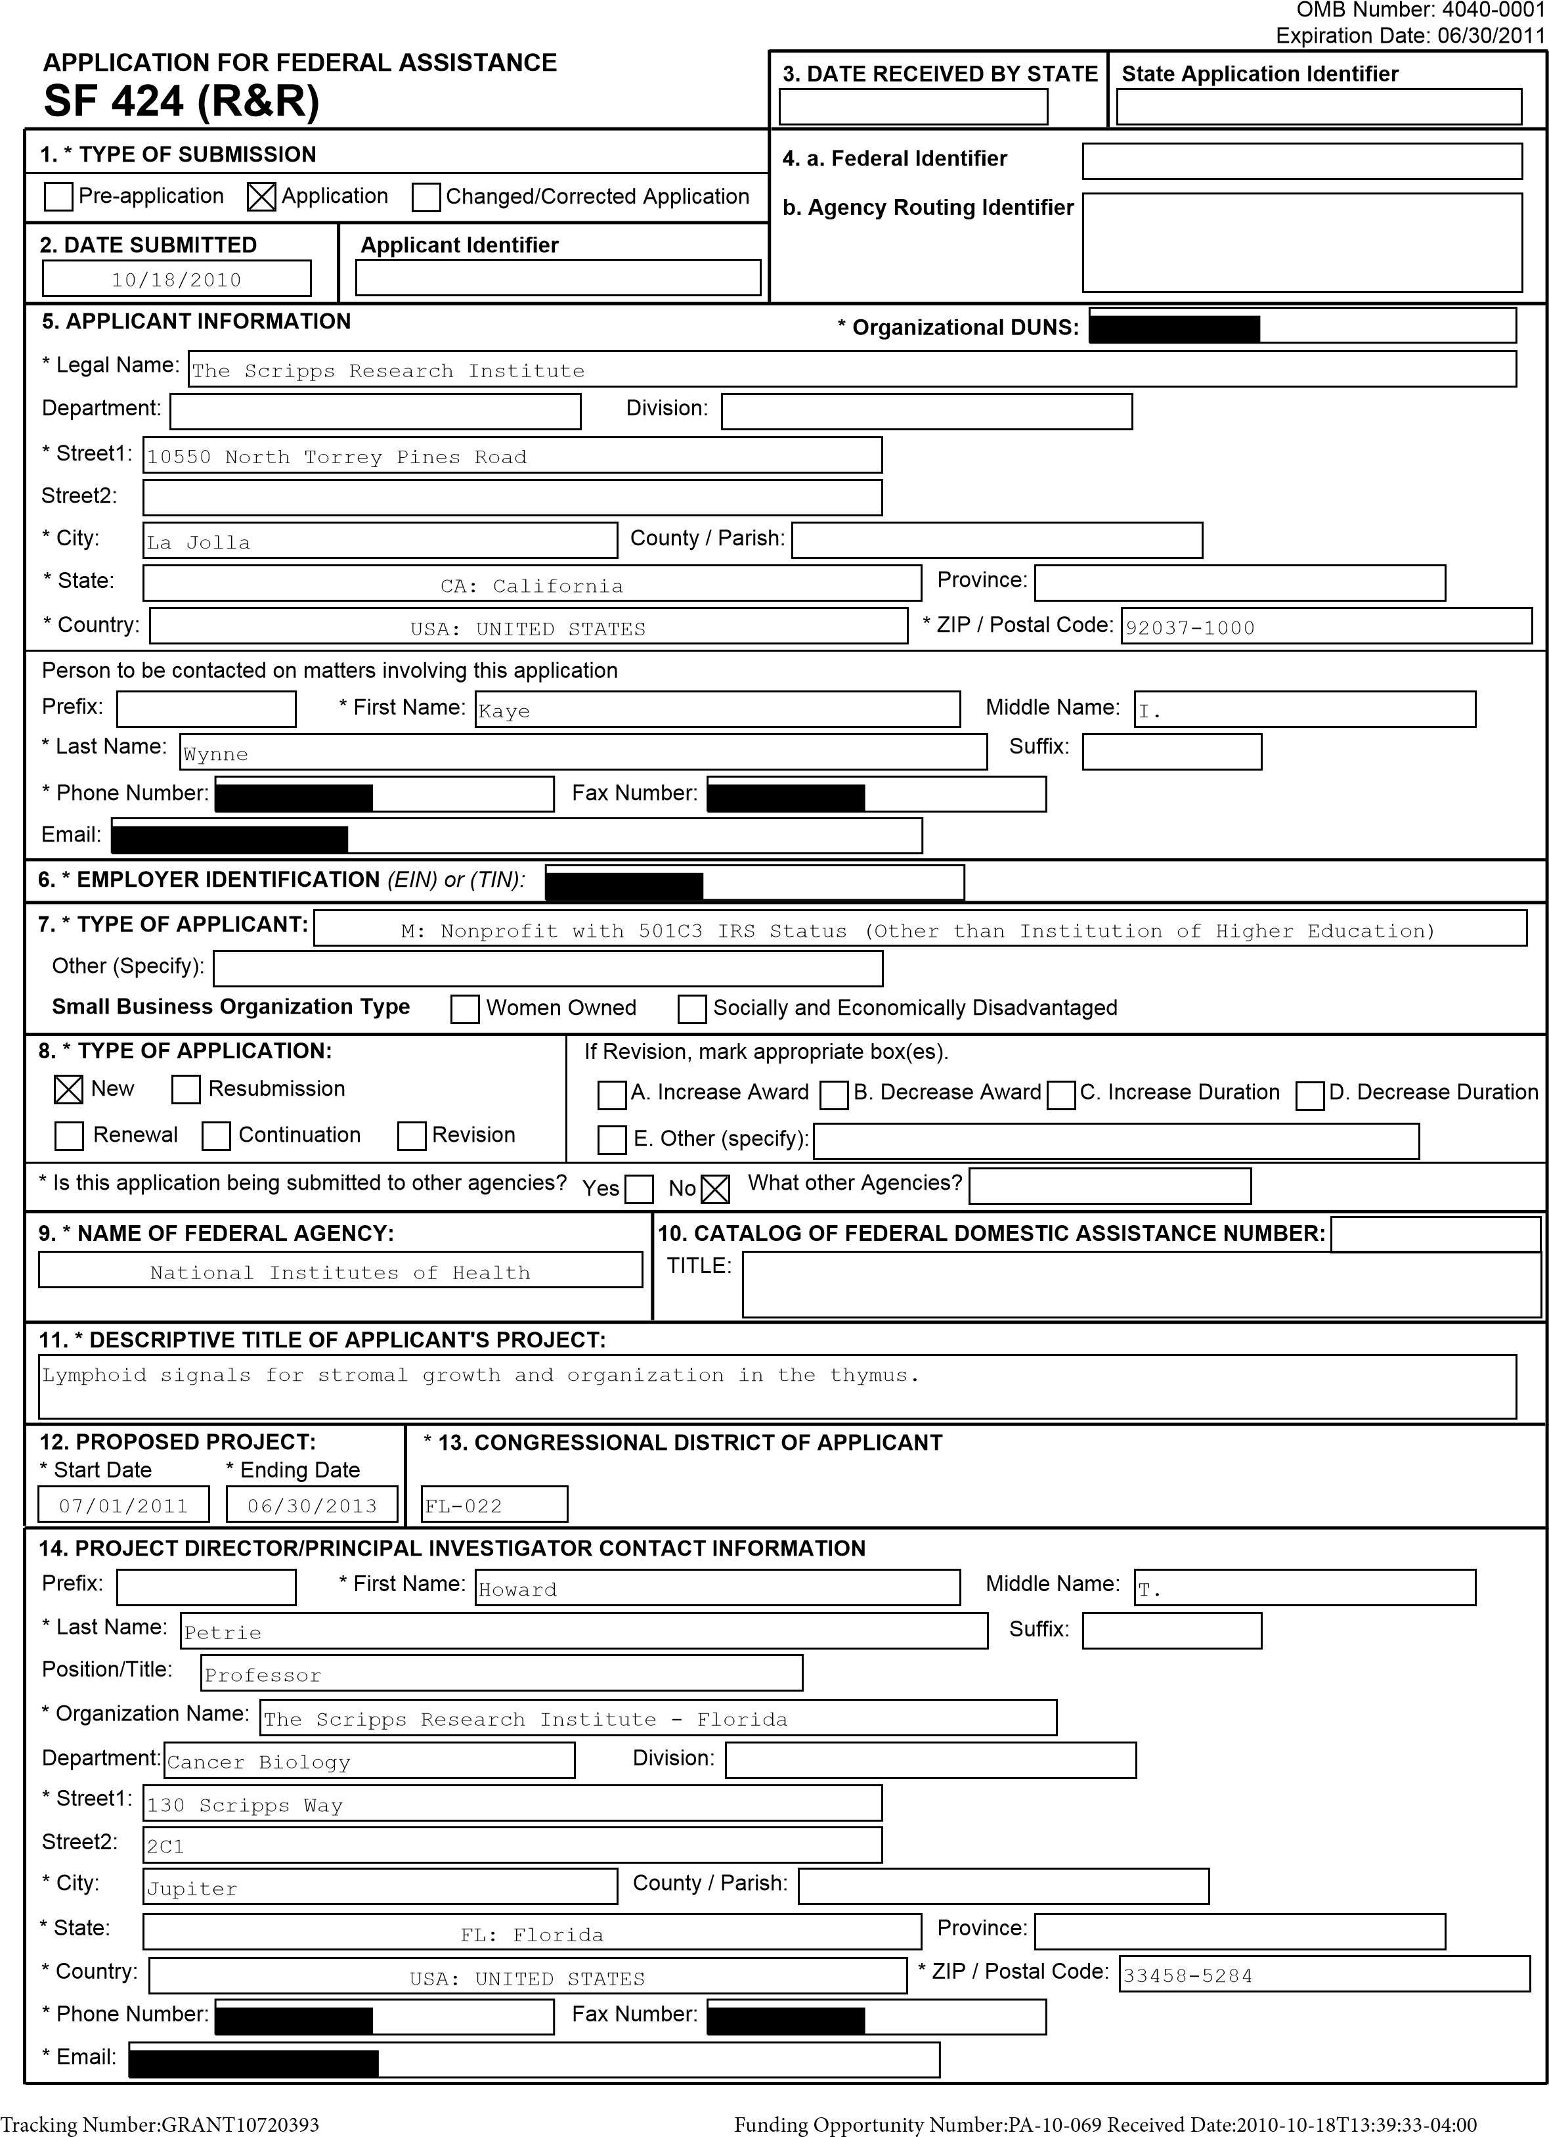
SF 424 (R&R) APPLICATION FOR FEDERAL ASSISTANCE Page 2
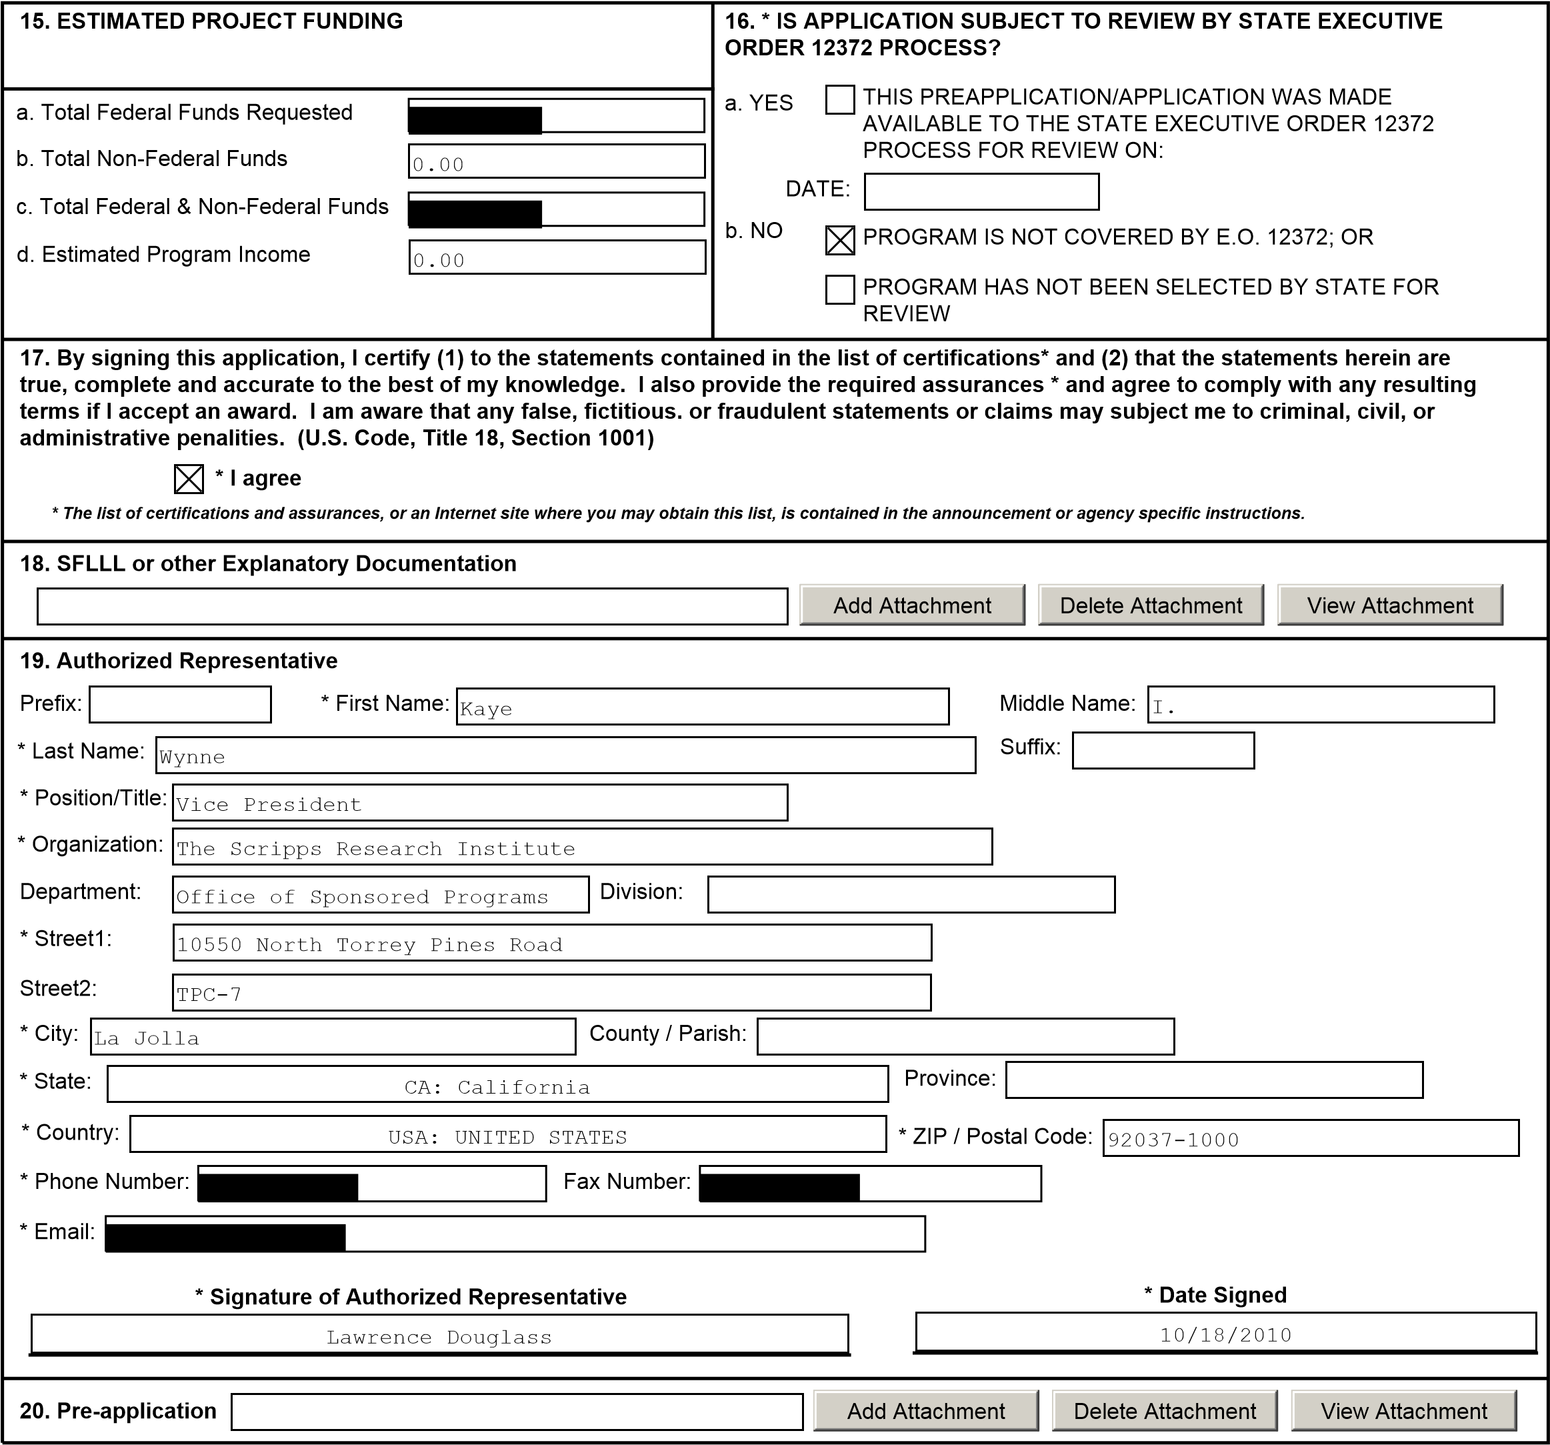
!""""#

424 R&R and PHS-398 Specific
Table Of Contents | Page Numbers
SF 424 R&R Face Page------------------------------------------------------------------------------------------ | 1
Table of Contents--------------------------------------------------------------------------------------------Performance Sites---------------------------------------------------------------------------------------------
3
4
5
6
7
8
10
11
13
16
18
21
22
23
24
30
31
32
35
36
Research & Related Other Project Information------------------------------------------------------------------
Project Summary/Abstract (Description)----------------------------------------
Public Health Relevance Statement (Narrative attachment)----------------------------------------
Facilities & Other Resources----------------------------------------
Equipment----------------------------------------
Research & Related Senior/Key Person------------------------------------------------------------------------- Biographical Sketches for each listed Senior/Key Person----------------------------------------
PHS 398 Specific Cover Page Supplement------------------------------------------------------------------------
PHS 398 Specific Modular Budget-------------------------------------------------------------------------------
Personnel Justification----------------------------------------
PHS 398 Specific Research Plan--------------------------------------------------------------------------------
Specific Aims--------------------------------------- Research Strategy----------------------------------------
Vertebrate Animals----------------------------------------
Bibliography & References Cited----------------------------------------
Letters of Support--------------------------------------- Resource Sharing Plan----------------------------------------
PHS 398 Checklist---------------------------------------------------------------------------------------------
Table of Contents Page 3
OMB Number: 4040-0010 Expiration Date: 08/31/2011

Project/Performance Site Location(s)
I am submitting an application as an individual, and not on behalf of a company, state, Project/Performance Site Primary Locationlocal or tribal government, academia, or other type of organization.
The Scripps Research Institute - Florida
Organization Name:
County:
* City:
Street2:
* Street1:
130
Scripps Way
Jupiter
DUNS Number:
FL: Florida
- State:
Province:
USA: UNITED STATES
- Country:
* ZIP / Postal Code:
33458-5284
FL-022
* Project/ Performance Site Congressional District:
Project/Performance Site Location
1
USA: UNITED STATES
* ZIP / Postal Code:
* Country:
Province:
* State:
* City:
Street2:
* Street1:
Organization Name:
County:
DUNS Number:
* Project/ Performance Site Congressional District:
I am submitting an application as an individual, and not on behalf of a company, state,
local or tribal government, academia, or other type of organization.
Add Attachment |  | Delete Attachment |  | View Attachment
Additional Location(s)
Performance Sites Page 4
!""""#
RESEARCH & RELATED Other Project Information
Is the IACUC review Pending?
. * Are Human Subjects Involved?
1
IRB Approval Date:
Human Subject Assurance Number:
2
. * Are Vertebrate Animals Used?
IACUC Approval Date:
If no, is the IRB review Pending?
2
.a.
If YES to Vertebrate Animals
6
5
3
2
1
4
Yes
No
.a
If YES to Human Subjects
1
Yes
No
Yes
No
If yes, check appropriate exemption number.
Yes
No
Yes
No
Is the Project Exempt from Federal regulations?
4.b. If yes, please explain:
Animal Welfare Assurance Number
4
.c. If this project has an actual or potential impact on the environment, has an exemption been authorized or an environmental assessment (EA) or
environmental impact statement (EIS) been performed?
6
. * Does this project involve activities outside of the United States or partnerships with international collaborators?
:
.b. Optional Explanation
6
. * Project Summary/Abstract
7
. * Is proprietary/privileged information included in the application?
3
.a. * Does this project have an actual or potential impact on the environment?
4
Yes
No
Yes
No
Yes
No
Yes
No
View Attachment
Delete Attachment
1234-
Summary.pdf
Add Attachment
5
. * Is the research performance site designated, or eligible to be designated, as a historic place?
Yes
No
4.d. If yes, please explain:
5.a. If yes, please explain:
6.a. If yes, identify countries:
1235-Narrative.pdf | Add Attachment Delete Attachment View Attachment
- * Project Narrative
1236-BiblioRef.pdf | Add Attachment Delete Attachment View Attachment
- Bibliography & References Cited
1237-Facilities.pdf | Add Attachment Delete Attachment View Attachment
- Facilities & Other Resources
1238-Equipment.pdf | Add Attachment Delete Attachment View Attachment
- Equipment
Add Attachments |  | Delete Attachments |  | View Attachments
- Other Attachments
Other Information Page 5
!""""#

PROJECT SUMMARY

Like all blood cells, T lymphocytes are constantly lost during life, and must be continuously replaced. The thymus is the primary site of de novo T lymphopoiesis. Microenvironmental conditions unique to the thymus induce a complex series of developmental events in multipotent, marrow-derived progenitors, including positive and negative control of proliferation, T lineage specification, functional T lineage asymmetry, self-restriction, self-tolerance, and cell death/survival signals. Significant progress has been made in understanding the signals the thymus provides to lymphoid progenitors to induce and control these events. However, the proliferation, differentiation, and/or survival of the non-lymphoid (stromal) components of the thymus are equally dependent on lymphoid cells, and the absence of lymphoid cells (e.g., congenital immunodeficiency diseases) results in athymia, even though the nascent stromal cells are functionally competent. The signals that lymphoid cells provide to induce stromal growth, differentiation, and/or survival are completely unknown. In this proposal, we propose to address this process in a comprehensive fashion. Using our recently devised method for global characterization of stromal gene expression in situ, we will analyze the dynamic response of stromal cells to the presence of lymphoid progenitors in an inducible model of thymic growth. We will then identify stromally-expressed genes that encode receptors, and thus may respond to the presence of lymphoid cells, with particular emphasis on those that change during specific phases of the growth response (induction, log phase, termination, steady-state). We will verify the presence of the cognate ligands for these receptors in lymphoid cells, using informatic methods as well as manual means of curation. Cognate receptor:ligand pairs will then be prioritized using a variety of criteria, including dynamic patterns of expression, known functional relevance (growth, differentiation, survival) in other tissues, the availability of existing genetic models, etc. Finally, the biological relevance of a few high-priority candidates will be tested, using appropriate stromalreceptor or lymphoid-ligand mutant mouse models. This project is expected to provide novel insights into an unexplored area of biology that will not only fuel a better understanding of this process, but will facilitate the development of more mechanistic studies to characterize the unique, two-way interactions that occur between lymphoid progenitors and stromal cells in the thymus.
Project Description Page 6

PROJECT NARRATIVE

The thymus is the primary organ where T lymphocytes are made, and thus is critical for normal immune function. Specialized cells inside the thymus (stromal cells) are responsible for instructing stem-like cells recruited from the bone marrow to undergo development into T lymphocytes. However, early in development, these stromal cells themselves require signals from immature lymphocytes to induce their own growth and development. In the absence of lymphocytes, for instance, as occurs in many pediatric immunodeficiency disorders, the thymus does not form. The goals of this project are to perform an in depth analysis of this very poorly understood two-way interplay between lymphocytes and stromal cells in the thymus, and how these processes shape the development of the immune system.
Public Health Relevance Statement Page 7

FACILITIES AND RESOURCES

Laboratory. The PI has ca. 3000 square feet of laboratory space at Scripps, containing all necessary small and large equipment (large equipment is described in another document, Major Equipment). There is more than sufficient space to carry out this project.

Clinical. n/a

Animal. Animals are housed in a new state-of-the-art facility of approximately 7000 square feet, including animal quarantine and holding rooms for rodents, dedicated procedure space, and a biosafety level 3 (BSL3) containment suite with shower-in requirement, biosafety cabinets, ventilated racks, and pass-through autoclave. Animal services are provided by a fully trained staff, including a full-time onsite staff veterinarian and oversight by the Scripps (La Jolla) head veterinarian.

Computer. Each employee (student, technician, or post-doctoral fellow) has a dedicated desktop computer, and access to several other networked computers in the laboratory. The PI has his own computer and access to all of Scripps’ computational resources.

Office. The PI has a ca. 175 ft. sq. private office with all necessary equipment, as well as 25% effort of an administrative assistant.

Other. The Flow Cytometry Core Facility (located adjacent to the PI’s laboratory) is equipped with a FACS Aria high-speed, four-way cell sorter with 405, 488, and 630 nm lasers and sheath/sample cooling, as well as a LSR2 analytical cytometer equipped with 350, 405, 488, 560, and 633 nm lasers. All equipment is readily accessible and so far is never used to capacity. The sorter is run by an institutionally-supported, trained operator, and is directed by the PI. All necessary equipment for proteomic analysis is located within the Proteomics Core of the Scripps Florida Research Institute.

Scientific environment. The Scripps Florida campus of The Scripps Research Institute (TSRI) establishes a new model for academia, where the Institute provides a unique environment and state-of-the-art infrastructure that are needed to launch and successfully complete academiadriven drug discovery/development campaigns. Discovery research is greatly facilitated by the Proteomics Core (collaborative effort discussed in this application), as well as a Cell-Based Screening Core (genome-wide cDNA and siRNA collections of both the mouse and human genomes), Genomics Core (Affymetrix gene chips, Illumina Deep Sequencing, and qPCR), and an Ultra-High Throughput Screening Facility (with in-house and NCI small molecule libraries that total greater than 900,000). TSRI, of which Scripps-Florida is an integrated part, is the world's largest, private non-profit biomedical research facility. The six Departments at the Scripps Florida campus (Cancer Biology, Chemistry, Infectology, Metabolism and Aging, Molecular
Therapeutics, and Neuroscience), join an existing nine Departments at the La Jolla campus of TSRI, which also houses twelve specialized Centers or Institutes and ~210 basic research faculty. There are synergistic interactions across all Departments and Centers of TSRI. Scripps Florida faculty and staff occupied three new, state-of-the-art research buildings (~390,000 total square feet) in November 2008 and the Institute will expand from its current roster of >40 faculty to eventually house ~75 faculty. The Cancer Biology Department is currently comprised of 10 tenure-track faculty and will expand to approximately 12-13 faculty. There are currently >100 Postdoctoral Associates at Scripps Florida and >40 (PhD- or MD-level) Staff Scientists. There are also 25 graduate students at Scripps Florida and this number will markedly increase over the next few years (there are ~220 graduate students at the La Jolla campus of TSRI). The
TSRI Graduate Program is very highly ranked, where Ph.D. with emphases in Structural
Biology, Chemistry, and Cell Biology, are ranked first, second, and eighth nationally,
Facilities Page 8
respectively. The Max Planck Florida Institute also joined the Scripps Florida campus this year, and is located on the adjacent property. Research at Max Planck Florida will focus on bioimaging, and their arrival they will bring in new in vivo imaging technologies that will have a
significant impact on the research programs of investigators of Scripps Florida.
Research Core Facilities will be shared between the two Institutes,
and the faculty of Max Planck Florida will have the option of joint appointments at TSRI and to be members of the TSRI PhD Program.

Early stage investigator: n/a

Special facilities: n/a
Facilities Page 9

MAJOR EQUIPMENT

The PI’s laboratory has the following dedicated equipment relative to this project: Microm HM505E cryostat; Olympus BX40 fluorescent microscope; two high-speed refrigerated centrifuges; tissue culture and bio-containment hoods and CO2 incubators; a full spectrum of general laboratory equipment (thermocyclers, micro-centrifuges, electrophoresis apparatus, etc).

The Flow Cytometry Core Facility (located adjacent to the PI’s laboratory) is equipped with a FACS Aria high-speed, four-way cell sorter with 405, 488, and 630 nm lasers and
sheath/sample cooling, as well as a LSR2 analytical cytometer equipped with 350, 405, 488, 560, and 633 nm lasers. All equipment is readily accessible and so far is never used to capacity. The sorter is run by an institutionally-supported, trained operator, and is directed by
the PI. The Flow Cytometry Core also houses and maintains the Leica AMD laser microdissection microscope, and offers training as well as for-fee operation for less skilled users.

The Microarray Core is located in a building adjacent to the one that houses the PI’s laboratory.
Major equipment includes an Agilent Bioanalyzer 2180 with a Dell Dimension 8300 computer, a
Nanodrop ND-1000 Spectrophotometer with a Dell Optiplex Gx280 computer, and all necessary Affymetrix hybridization and fluidics stations. The Bioanalyzer and Nanodrop are available to end-users, while the Affymetrix equipment is restricted to dedicated core personnel.

The major computer equipment available for this project is housed and maintained by the Information Technology group at Scripps. This includes a high-performance computer cluster consisting of 200 AMD-64 processors running at 2.0 GHz, each node of which has 2 Gb of dual-rate RAM, providing each processor with a dedicated memory path. Combined with the native 64-bit capabilities of the processor, this memory path allows us to tackle problems of the size and complexity necessary for the proposed project. The cluster is tied together using a high-speed network interconnect, capable of carrying data at 1Gbit per second. A multi Terra-Byte storage solution is also attached. The large capacity of the storage arrays allows comparative and iterative work, such as that proposed in this project, to be done in an extremely fast manner. Data access and retrieval is accomplished with a cutting edge file system, able to provide data transfer speeds to disk at line speed rates (1 GBit). This oftenoverlooked aspect becomes critical when dealing with large datasets such those generated by the proposed project. Another unique aspect of the Scripps-Florida computer cluster is the tight integration of the database environment with a Storage Attached Network (SAN) environment, thus facilitating sharing of data in relational as well as flat file formats to the cluster with minimal latency. This computing power and expertise is easily sufficient to accommodate all of the needs of the proposed project.
Equipment Page 10
OMB Number: 4040-0001
Expiration Date: 06/30/2011
RESEARCH & RELATED Senior/Key Person Profile (Expanded)
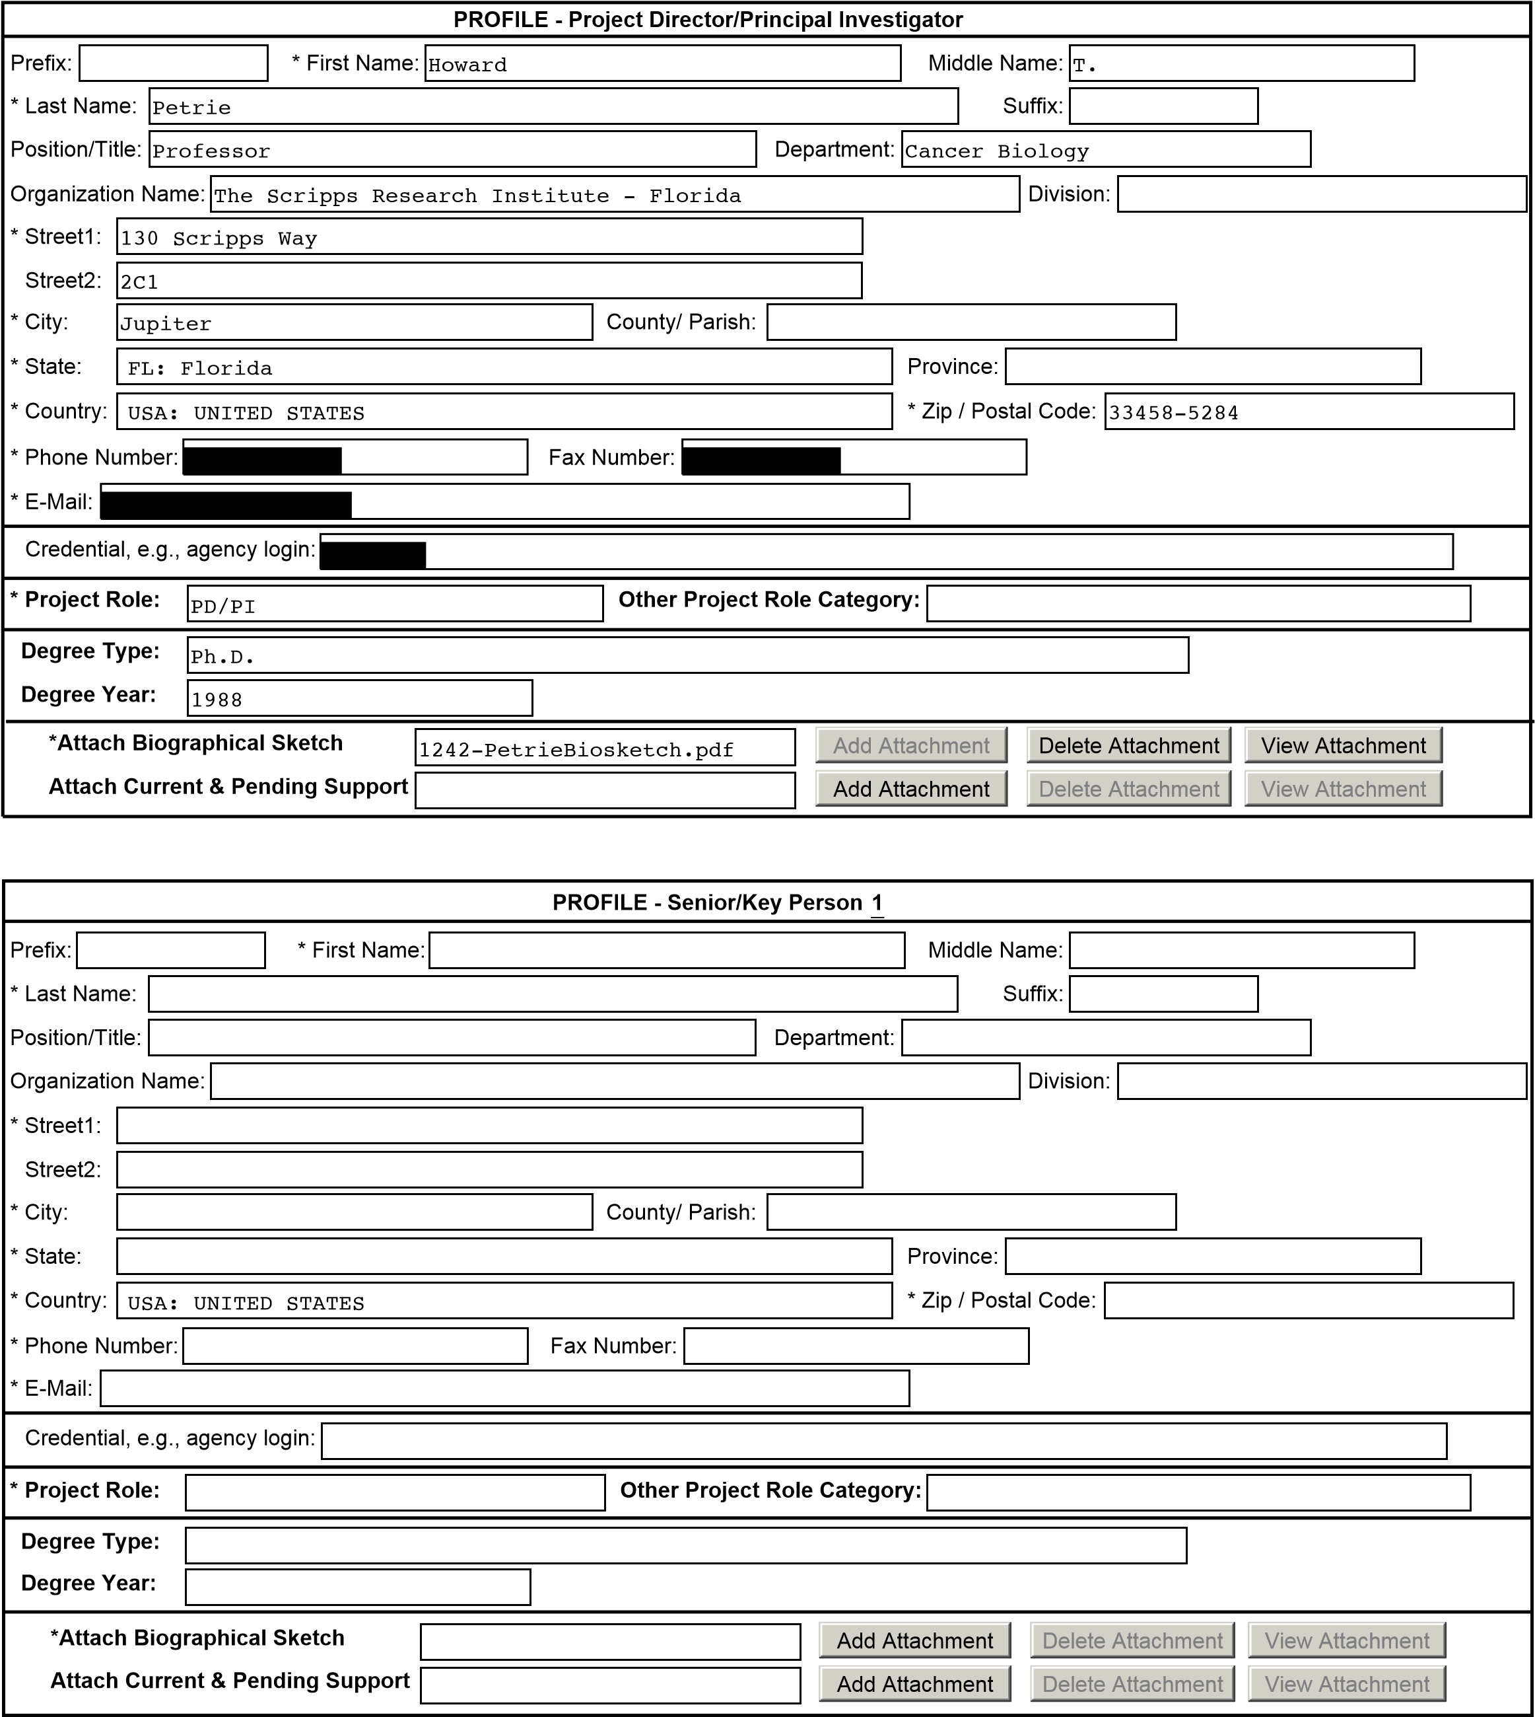
To ensure proper performance of this form; after adding 20 additional Senior/ Key Persons; please save your application, close the Adobe Reader, and reopen it.
Key Personnel Page 11
Add Attachment |  | Delete Attachment | View Attachment
!""""# ADDITIONAL SENIOR/KEY PERSON PROFILE(S)
Add Attachment |  | Delete Attachment | View Attachment
Additional Biographical Sketch(es) (Senior/Key Person)
Add Attachment |  | Delete Attachment | View Attachment
Additional Current and Pending Support(s)
Key Personnel Page 12
!""""#
 |  | BIOGRAPHICAL SKETCH
NAME  Petrie, Howard Terrence |  |  | POSITION TITLE Professor
eRA COMMONS USER NAME
EDUCATION/TRAINING (Begin with baccalaureate or other initial professional education, such as nursing, and include postdoctoral training.)
INSTITUTION AND LOCATION | DEGREE  (if applicable) | YEAR(s) | FIELD OF STUDY
Pennsylvania State University, University Park, PA | BS | 1974-78 | Microbiology
Pennsylvania State University, University Park, PA | MS | 1980-81 | Microbiology
University of Nebraska Medical Center, Omaha, NE | PhD | 1984-88 | Immunology
A. Personal Statement.

I have been an independent investigator since 1993. I have been a peer reviewed, NIH funded investigator since 1994. My area of interest and expertise has always been the role of the thymic microenvironment on lymphoid progenitor differentiation. Research from my laboratory was essential in revealing the patterned migration of bone marrow derived progenitor cells within the thymus during differentiation. Since that time, we have been actively involved in further understanding the how this migration impacts the developmental process, as well as the mechanisms that induce or support migration. The present application is a clear extension of these studies.

B. Positions and Employment.
1978-1980 Research Technologist, Department of Microbiology, Pennsylvania State University, University Park, PA
1981-1983 Technical Coordinator, Bellco Glass, Inc., Vineland, NJ
1983-1988 Research Associate / Biological Scientist, Department of Internal Medicine /Research Service,
The University of Nebraska and Veteran’s Administration Medical Centers, Omaha, NE
1988-1992 Postdoctoral Fellow, Lymphocyte Differentiation Unit, The Walter and Eliza Hall Institute of Medical Research, Melbourne, Australia
1992-1993 Postdoctoral Fellow, Section of Immunobiology, Yale University School of Medicine, New Haven, CT
1993-2004 Assistant Member/Associate Member, Immunology Program, Sloan-Kettering Institute, Assistant Professor, Cornell University Graduate School of Medical Sciences, NY, NY
2004-2005 Professor, Department of Microbiology and Immunology, University of Miami School of Medicine, Miami, FL
2005-present Professor, Department of Cancer Biology, The Scripps Research Institute, Jupiter, FL. Other experience:
1998-2000 Associate Editor, The Journal of Immunology
December 2000 Guest Editor, Seminars in Immunology
2000-2004 Section Editor, The Journal of Immunology
2002-2006 Associate Editor, Clinical and Developmental Immunology C. Selected peer-reviewed publications:
1. Petrie HT, Livak F, Schatz DG, Strasser A, Crispe IN, and Shortman K. 1993. Multiple rearrangements in T cell receptor γ-chain genes maximize the production of useful thymocytes. J. Exp. Med., 178:615-622. 2. Dudley EC, Petrie HT, Shah L, Owen MJ, and Hayday AC. 1994. T cell receptor β chain gene rearrangement and selection during thymocyte development in adult mice. Immunity 1:83-93.
- Wayne J, Suh H, Sokol KA, Petrie HT, Witmer-Pack M, Edelhoff S, Disteche CM and Nussenzweig MC. 1994. TCR selection and allelic exclusion in RAG transgenic mice that exhibit abnormal T cell localization in lymph nodes and lymphatics. J. Immunol. 153:5491-5502.
- Livak F, Petrie HT, Crispe IN, and Schatz DG. 1995. In-frame TCR-δ gene rearrangements play a critical role in the αβҡγδ T cell lineage decision. Immunity 2:617-628.
- Petrie HT, Livak F, Burtrum D, and Mazel S. 1995. TCR gene recombination patterns and mechanisms:
cell death, rescue, and T cell production. J. Exp. Med. 182:121-127.

Biosketches Page 13
- Mazel S, Burtrum D, and Petrie HT. 1996. Regulation of cell division cycle progression by bcl-2: a potential mechanism for the inhibition of programmed cell death. J. Exp. Med. 183:2219-2226.
- Burtrum DB, Kim S, Dudley EC, Hayday AC, and Petrie HT. 1996. TCR gene recombination and αβҡγδ lineage divergence: productive TCR-β rearrangement is neither exclusive nor preclusive of γ/δ cell development. J. Immunol. 157:4293-4296.
- Tourigny M, Mazel S, Burtrum DB, and Petrie HT. 1997. TCR-β gene recombination: dissociation from cell cycle regulation and developmental progression during T cell ontogeny. J. Exp. Med: 185:1549-1556 9. Murgia C, Blaikie P, Kim N, Dans M, Petrie HT, and Giancotti F. 1998. A targeted deletion of the integrin β4 cytoplasmic domain causes separate cell adhesion and cell cycle defects. EMBO J. 17:3940-3951.
- Livak F, Tourigny M, Schatz DG, and Petrie HT. 1998. Characterization of T cell receptor (TCR) gene rearrangements during adult murine T cell development. J. Immunol.162:2575-2580.
- Lind E, Wayne J, Wang Q-Z, Staeva T, Stolzer A, and Petrie HT. 1999. Bcl-2-induced changes in E2F regulatory complexes reveal the potential for integrated cell cycle and cell death functions. J. Immunol. 162:5374-5379.
- King LB, Tolosa E, Lu F, Lenczowski JM, Lind EF, Hunziker R, Petrie HT, and Ashwell JD. 1999. A Dominant-negative mutant of c-Jun inhibits cell cycle progression during the transition of CD4- 8- to CD4+8+ thymocytes. Int. Immunol. 11:1203-1216.
- Petrie HT, Tourigny M., Burtrum DB., Mazel S., and Livak F. 2000. Precursor thymocyte differentiation and proliferation are controlled by microenvironmental signals unrelated to the pre-TCR. J Immunol. 165:3094-3098.
- Livak F, Burtrum DB, Rowen L, Schatz DG, and Petrie HT. 2000. Genetic modulation of TCR gene segment usage during somatic recombination. J. Exp. Med. 192: 1191-1196.
- Lind E, Prockop S, Porritt H, and Petrie HT. 2001. Mapping precursor movement through the post-natal thymus reveals specific microenvironments supporting defined stages of early lymphoid development. J. Exp. Med. 194:127-134.
- Yannoutsos N, Wilson P, Yu W, Chen HT, Nussenzweig A, Petrie HT, and Nussenzweig MC. 2001. The role of recombination activating gene (RAG) reinduction in thymocyte development in vivo. J. Exp. Med. 194:471-80.
- Prockop S, Palencia S, Ryan CM, Gordon K, Gray D, and Petrie HT. 2002. Stromal cells provide the adhesion matrix for migration of early lymphoid progenitors through the thymic cortex. J. Immunol. 169:4354-4561.
- Gordon K, Duckett L, Daul B, and Petrie HT. 2003. A simple method for detecting up to five immunofluorescent parameters together with DNA staining for cell cycle or viability on a benchtop flow cytometer. J. Immunol..Methods, 275:113-21.
- Lepique AP, Palencia S, Irjala H, and Petrie HT. 2003. Characterization of vascular adhesion molecules that may facilitate progenitor homing in the post-natal mouse thymus. Clin. Dev. Immunol. 10:27-33.
- Porritt H, Gordon K, and Petrie HT. 2003. Kinetics of steady-state differentiation and mapping of intrathymic signaling environments by stem cell transplantation in non-irradiated mice. J. Exp. Med.
198:957-62.
- Plotkin J, Prockop SE, Lepique A, and Petrie HT. 2003. Critical role for CXCR4 signaling in progenitor localization and T cell differentiation in the post-natal thymus. J. Immunol. 171:4521-7.
- Prockop SE, and Petrie HT. 2004. Functional assessment of alphaEbeta7/E-cadherin interactions in the steady state postnatal thymus. Clin. Dev. Immunol. 11:135-41.
- Prockop SE, and Petrie HT. 2004. Regulation of thymus size by competition for stromal niches among early T cell progenitors. J. Immunol, 173:1604-11.
- Schmitt TM, Ciofani M, Petrie HT, Zuniga-Pflucker JC. 2004. Maintenance of T cell specification and differentiation requires recurrent notch receptor-ligand interactions. J. Exp. Med. 200: 469-79.
- Misslitz A, Pabst O, Hintzen G, Ohl L, Kremmer E, Petrie HT, Forster R. 2004. Thymic T cell development and progenitor localization depend on CCR7. J. Exp. Med. 200: 481-91.
- Tabrizifard S, Olaru A, Plotkin J, Fallahi-Sichani M, Livak F, and Petrie HT. 2004. Analysis of transcription factor expression during discrete stages of post-natal thymocyte differentiation reveals potentials novel regulators of differentiation and proliferation. J. Immuol,. 173:1094-102.
- Porritt HE, Schmitt TM, Rumfelt LL, Tabrizifard S, Zuniga-Pflucker JC, and Petrie HT. 2004. Heterogeneity among DN1 prothymocytes reveals multiple progenitors with different capacities to generate T cell and non-T cell lineages. Immunity, 20:735-45.
- Huang J, Garrett KP, Pelayo R, Zúñiga-Pflücker JC, Petrie HT, Kincade PW. 2005. Propensity of adult lymphoid progenitors to progress to DN2/3 stage thymocytes with Notch receptor ligation. J. Immunol,
175:4858-4865
Biosketches Page 14

- Schwartz R, Engel I, Fallahi-Sichani M, Petrie HT, and Murre C. 2006. Gene expression patterns define novel roles for E47 in cell cycle progression, cytokine-mediated signaling, and T lineage development. Proc.
Natl. Acad. Sci. (USA) 103:9976-81.
- Petrie HT and Zuniga-Pflucker JC. 2007. Zoned out: functional mapping of stromal signaling microenvironments in the thymus. Annu Rev Immunol 25:649-79.
- Umland O, Mwangi W, Anderson B, Walker J, and Petrie HT. 2007. The Blood Contains Multiple Distinct Progenitor Populations with Clonogenic B and T Lineage Potential. J Immunol 178:4147-4152. 47.
- Gosink MM, Petrie HT, and Tsinoremas NF. 2007. Electronically subtracting expression patterns from a mixed cell population. Bioinformatics 23:3328-3334.
- Griffith AV, Fallahi M, Nakase H, Gosink M. 2009. Young B, and Petrie HT. Spatial mapping of thymic stromal microenvironments reveals unique features influencing T lymphoid differentiation. Immunity 31:9991009. PMCID PMC2807413.

D. Research Support:

Ongoing.

1R01AG031576 Petrie (PI) 02/01/09 - 01/31/14
Identification of stromal responses during castration-induced thymic regrowth.

The major goals of this project are to use our recently devised differential gene mapping approach (see Griffith et al., above) to measure gene expression changes in young thymic stromal cells, old thymic stromal cells, and thymic stromal cells undergoing regeneration in response to surgical castration. These gene expression changes will then be used to identify growth and survival pathways in stromal cells, and to probe their biology. The informatic methodologies used in this project are exactly those that are required for the current proposal.

Completed.

1R21AI067453 Petrie 01/15/06 -12/31/07
Transcriptional Mapping of Thymic Stromal Microenvironments

The major goals of this project were to use tissue microdissection and global gene expression profiling to characterize thymic stromal cells from functionally-defined tissue sub-regions of the thymus, and to identify subregion-specific signals that induce specific developmental events in progenitor T cells. The skills and knowledge gained during the execution of this project are completely and uniquely relevant to the current proposal.

1R21AI053739 Petrie 01/01/03 - 12/31/04
Signals for lineage commitment in the post-natal thymus

The major goals of this project were to use microarray profiling of RNA from purified progenitor thymocytes to identify genes, and particularly, surface receptors, that change during lymphoid development in the thymus. The biological and informatic techniques developed for this project are exactly those that will be used for the current project.
Biosketches Page
PHS 398 Cover Page Supplement OMB Number: 0925-0001

1. Project Director / Principal Investigator (PD/PI)
Howard
Prefix: * First Name:
T.
Middle Name:
Petrie
* Last Name:
Suffix:
2. Human Subjects
Clinical Trial?
No
Yes
No
Yes
* Agency-Defined Phase III Clinical Trial?
3. Applicant Organization Contact
Person to be contacted on matters involving this application
 | * First Name: | Kaye
I.
Prefix:
Middle Name:
Wynne
- Last Name:
Suffix:
- Phone Number:Fax Number:
Email:
V.P., Office of Sponsored Programs
- Title:
10550 North Torrey Pines Road
TPC-7
- Street1:Street2:
La Jolla
- City:
County/Parish:
CA: California
- State:
Province:
USA: UNITED STATES | * Zip / Postal Code: | 92037-1000
- Country:
Clinical Trial & HESC Page 16
PHS 398 Cover Page Supplement
4. Human Embryonic Stem Cells
* Does the proposed project involve human embryonic stem cells?
Yes
No
If the proposed project involves human embryonic stem cells, list below the registration number of the specific cell line(s) from the following list: http://stemcells.nih.gov/research/registry/. Or, if a specific stem cell line cannot be referenced at this time, please check the box indicating that one from the registry will be used:
Cell Line(s): Specific stem cell line cannot be referenced at this time. One from the registry will be used.

Clinical Trial & HESC Page

PHS 398 Modular Budget, Periods 1 and 2
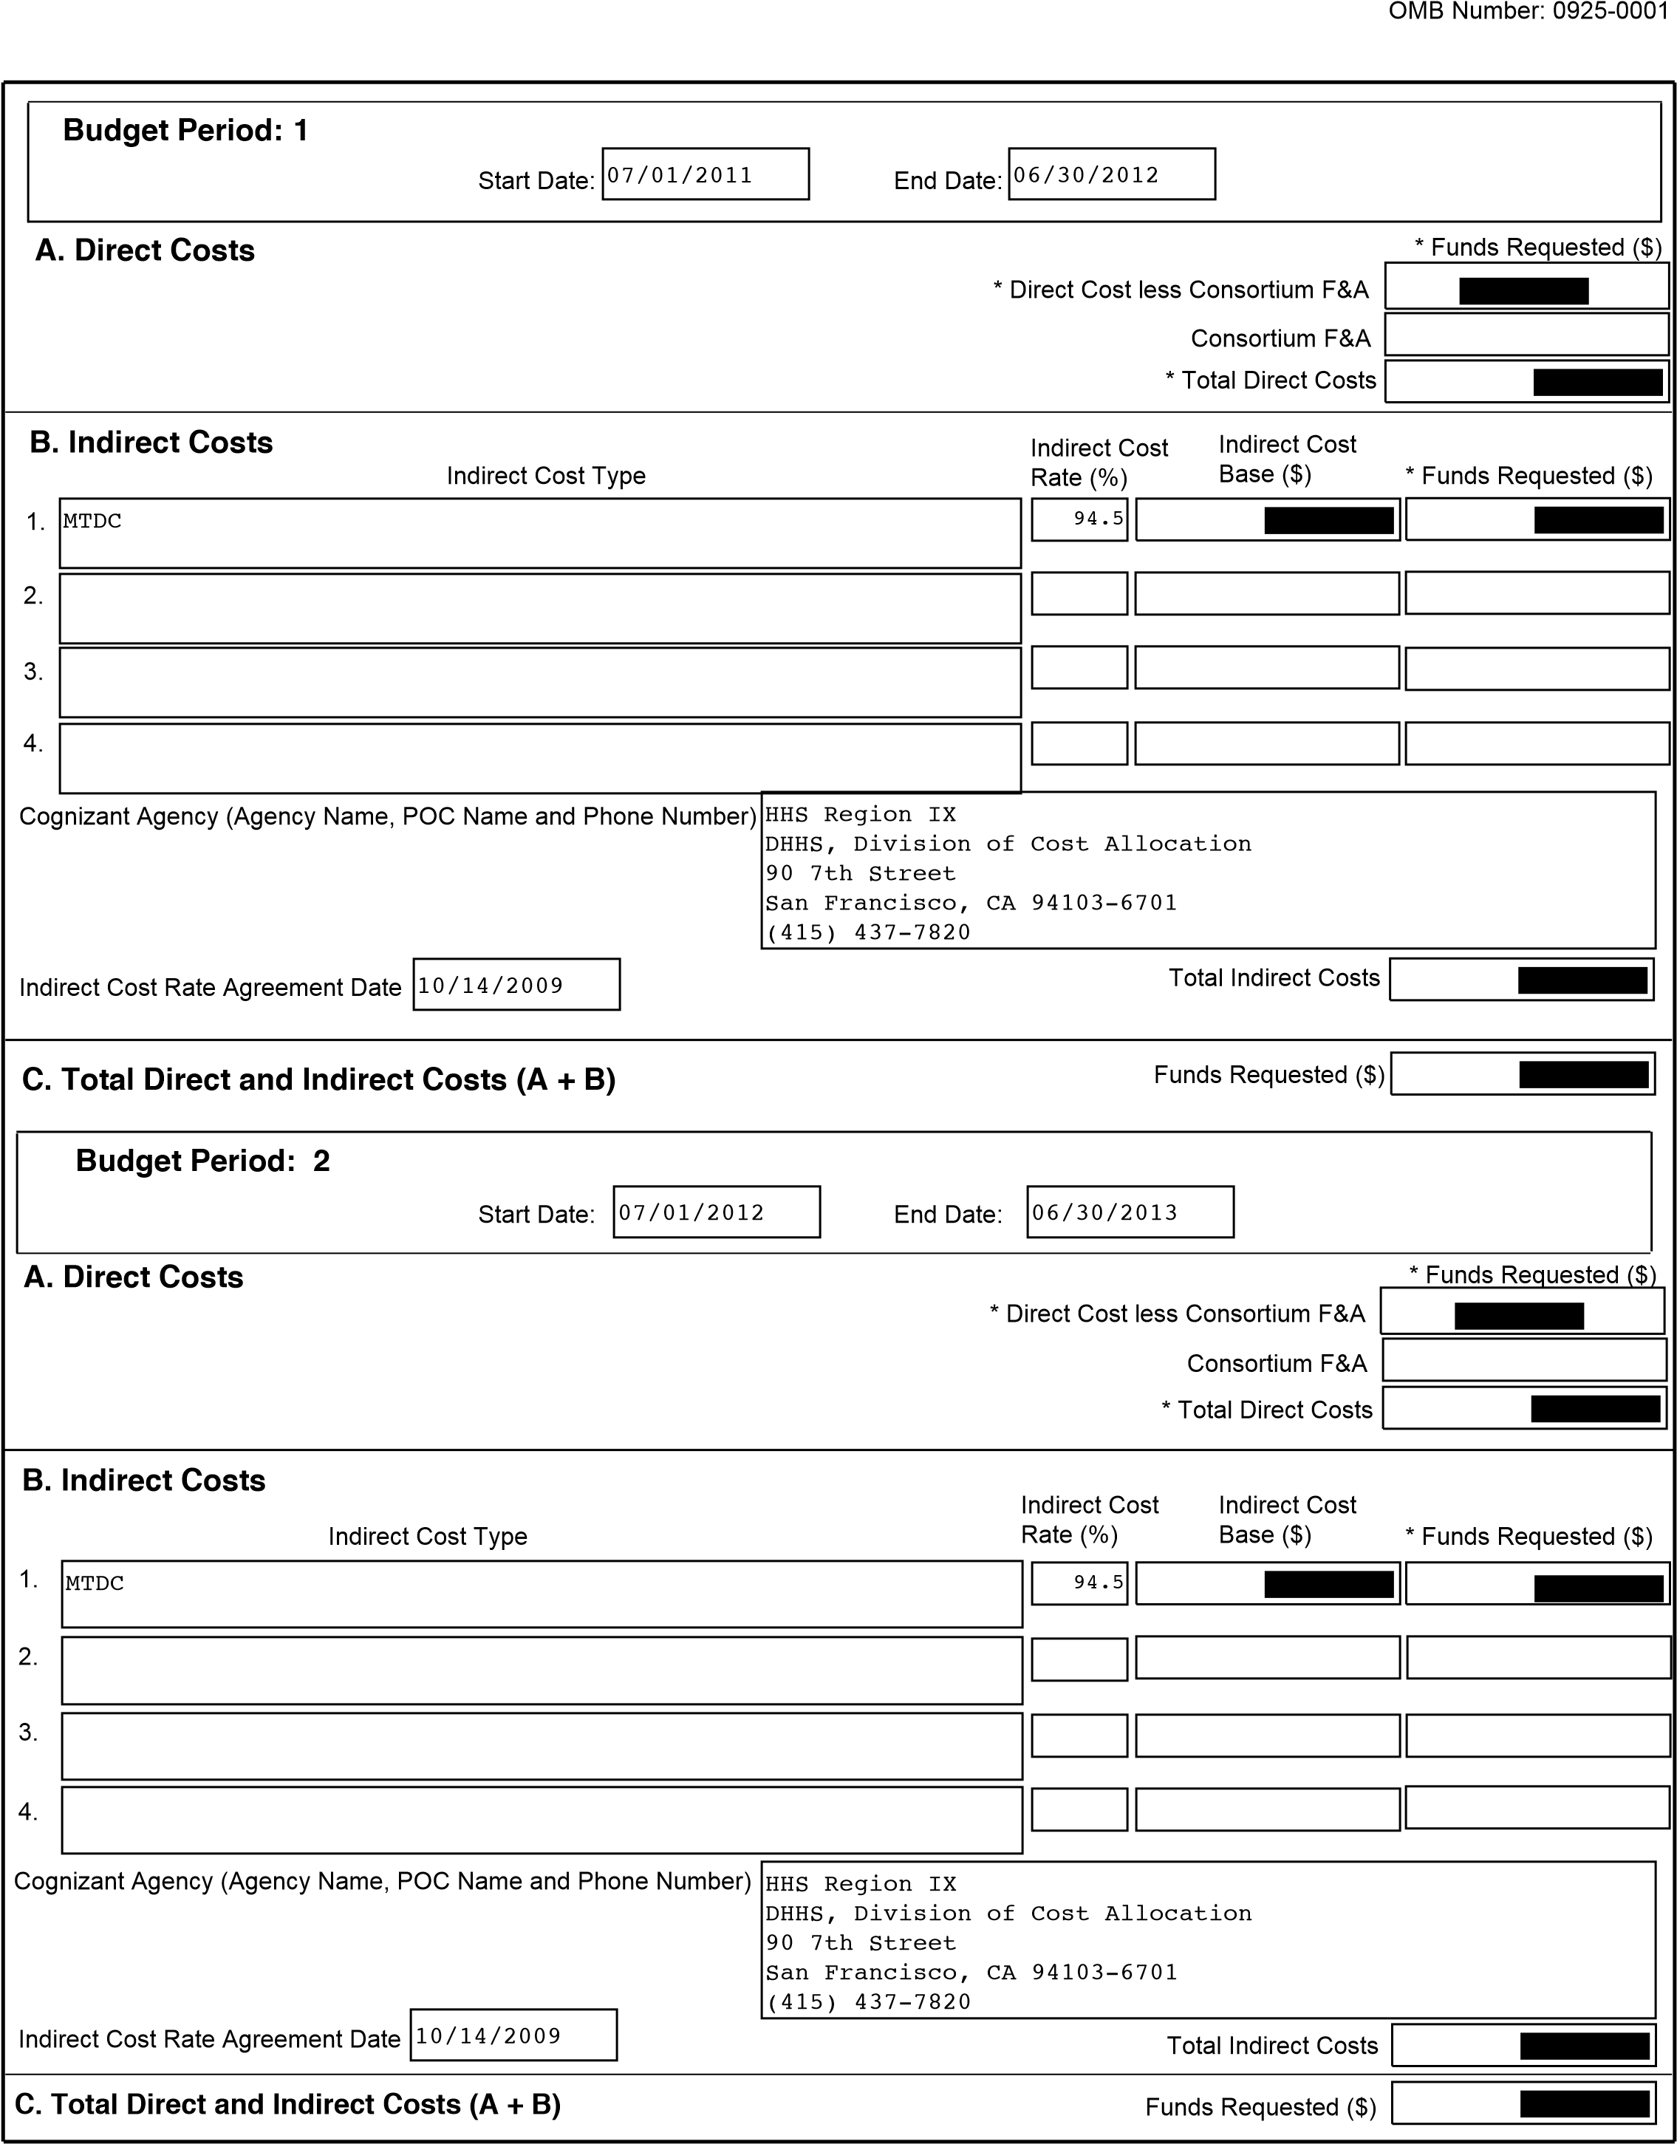
Modular Budget Page 18

PHS 398 Modular Budget, Periods 3 and 4

.
1
Start Date:
End Date:
Budget Period:
3
* Direct Cost less Consortium F&A
A. Direct Costs
B. Indirect Costs
Consortium F&A
* Total Direct Costs
Indirect Cost Type
Indirect Cost
Rate (%)
Indirect Cost
Base ($)
* Funds Requested ($)
Co
gnizant Agency (Agency Name, POC Name and Phone Number)
Ind
irect Cost Rate Agreement Date
Total Indirect Costs
)
Funds Requested ($
C.
Total Direct and Indirect Costs (A + B)
.
2
.
3
.
4
.
1
Start Date:
End Date:
Budget Period: 4
*
Direct Cos
t less Consortium F&A
A.
Direct Costs
Indirect Costs
B.
Consortium F&A
* Total Direct Costs
Indirect Cost Type
Indirect C
ost
Rate (%)
Indirect Cost
Base ($)
* Funds Requested ($)
Cognizant Agency (Agency Name, POC Name and Phone Number)
Indirect Cost Rate Agreement Date
Total Indirect Costs
Funds Requested ($)
C. Total Direct and Indirect Costs (A + B)
2
.
3
.
.
4
* Funds Requested ($)
* Funds Requested ($)
Modular Budget Page

PHS 398 Modular Budget, Periods 5 and Cumulative
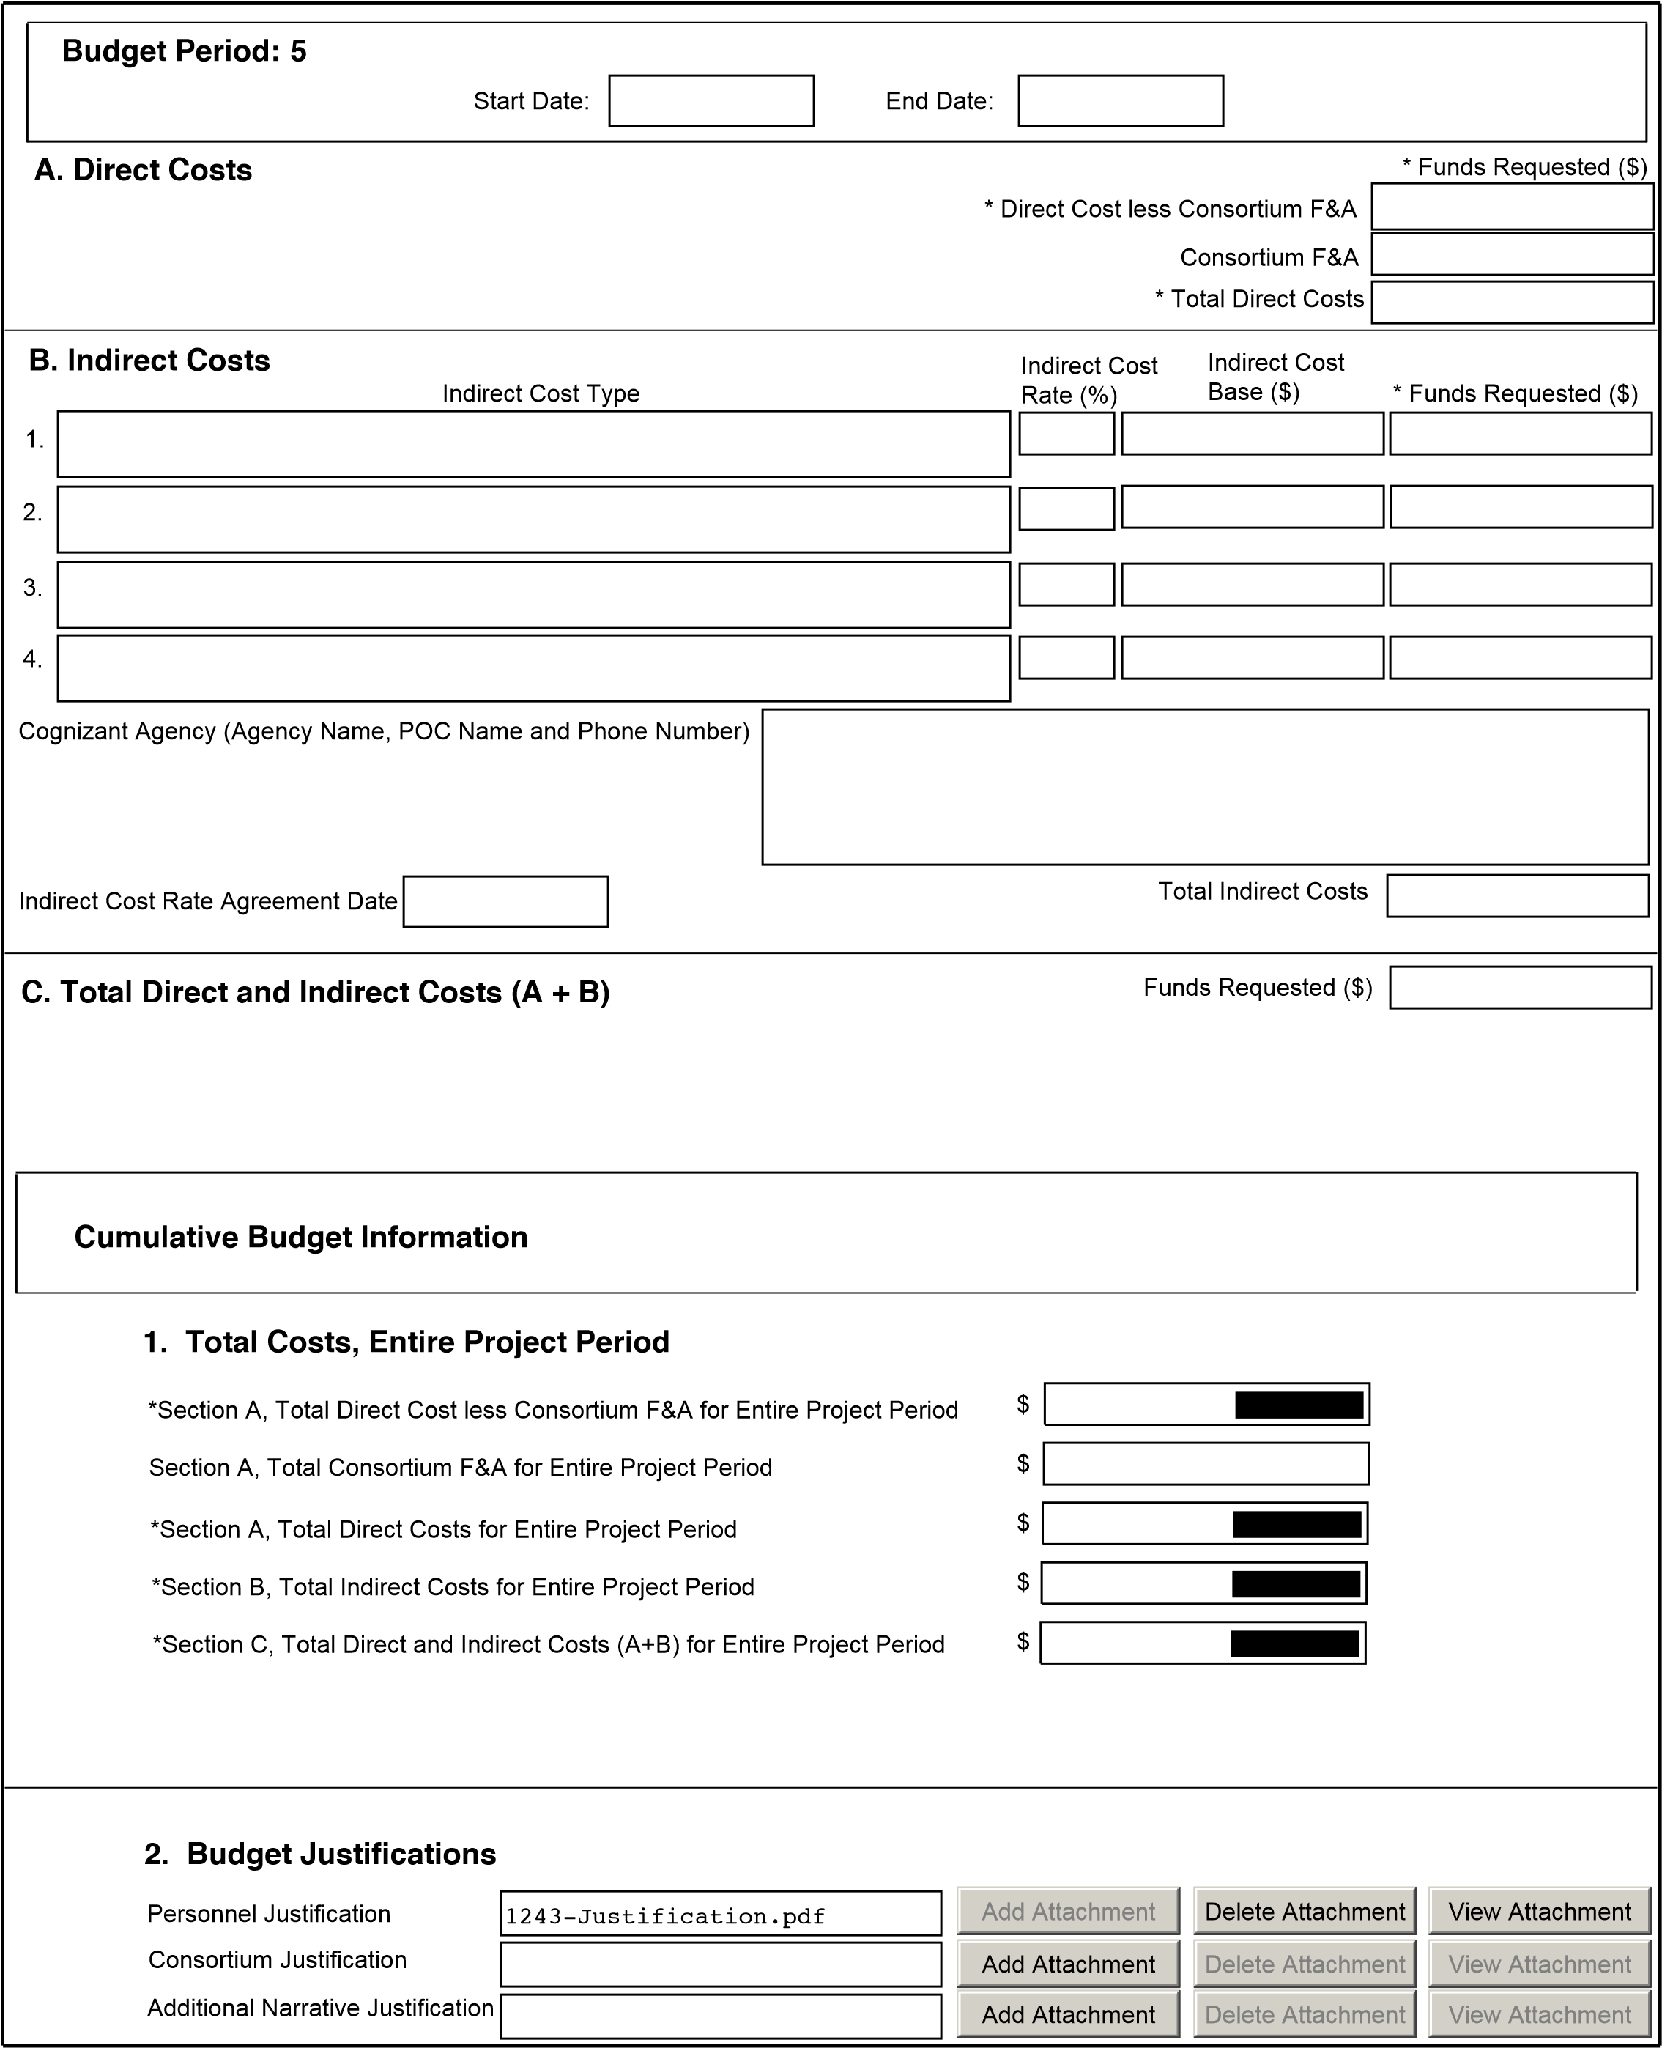
Modular Budget Page 20

PERSONNEL JUSTIFICATION

Howard T Petrie, Ph.D. Principal Investigator. 1.2 calendar months. Note that the PI is required to generate 100% support for his own salary and fringe benefits, as well 100% of the salary and fringe benefits of his employees and/or trainees. The PI will be solely responsible for project oversight. This includes supervising and training the postdoctoral fellow (100% effort, below) in both biological and informatic techniques, and supervising the informatic specialist (10% effort, below), and the interactions between these two individuals. Where necessary (historically, very frequently), the PI will directly assist in biological procedures, either to help to move projects more rapidly to completion, or for the purposes of demonstration and training for the PDF. The PI will also be responsible for noncompetitive renewal application (s), animal protocols, and other reporting requirements. The PI will monitor the budget to ensure that the project remains within the range available resources. The PI will review all raw data in detail prior to submission for publication, and will write the manuscripts that result. The PI, and/or the post-doctoral fellow, may also be responsible for presenting the data at conferences.

To be named, Ph.D. Post-doctoral fellow. 12 calendar months. The post-doctoral fellow will carry out the majority of the biological and informatic procedures described in this proposal, with assistance and training from the PI and the informatic scientist (below). The PDF will interact closely with the PI to develop biological insights and revise the approach as necessary. The PDF will be responsible for organizing data into a state that is comprehensible for review by the PI for progress reports and publication, and may assist in the writing of manuscripts. The PDF may be responsible for presentation of the data at conferences. Note that at the completion of this project, the PDF will possess a very desirable set of skills that involve thymus biology, genetic modeling, and informatic data mining. These skills are very relevant for the future, and will greatly benefit the PDF in the development of his/her career.

Mohammad Fallahi, M.S. Informatic Scientist. 1.2 calendar months. The informatic scientist is currently shared between the PI and two other investigators at Scripps. He does not, himself, have adequate additional effort available to devote to the proposed project: months 7 through 12 (approximately) of the proposed project will require a 100% effort for processing the data generated during months 1-6. During the entire project, the PDF will receive hands-on training from the informatic scientist, and training and supervision from the PI, to develop the skills to go from raw microarray data to candidate receptor:ligand interactions for biological validation (year 2). The informatic scientist has worked with the PI for more than 7 years, and is very skilled in the relevant techniques, as well as being a skilled and patient teacher.
Personnel Justification Page
OMB Number: 0925-0001

PHS 398 Research Plan
1. Application Type:
From SF 424 (R&R) Cover Page. The response provided on that page, regarding the type of application being submitted, is repeated for your reference, as you attach the appropriate sections of the Research Plan.
*Type of Application:
New Resubmission Renewal Continuation Revision
2. Research Plan Attachments:
Please attach applicable sections of the research plan, below.
Add Attachment |  | Delete Attachment |  | View Attachment
- Introduction to Application
(for RESUBMISSION or REVISION only)
1240-SpecAims.pdf |  | Add Attachment |  | Delete Attachment |  | View Attachment
- Specific Aims
1241-ResStrategy.pdf |  | Add Attachment |  | Delete Attachment |  | View Attachment
- *Research Strategy
Add Attachment |  | Delete Attachment |  | View Attachment

Add Attachment |  | Delete Attachment |  | View Attachment

- Inclusion Enrollment Report
- Progress Report Publication List
Human Subjects Sections
Add Attachment |  | Delete Attachment |  | View Attachment

Add Attachment |  | Delete Attachment |  | View Attachment

Add Attachment |  | Delete Attachment |  | View Attachment

Add Attachment |  | Delete Attachment |  | View Attachment

- Protection of Human Subjects
- Inclusion of Women and Minorities
- Targeted/Planned Enrollment Table
- Inclusion of Children
Other Research Plan Sections
1244-VertAnim.pdf |  | Add Attachment |  | Delete Attachment |  | View Attachment
- Vertebrate Animals
Add Attachment |  | Delete Attachment |  | View Attachment

Add Attachment |  | Delete Attachment |  | View Attachment

Add Attachment |  | Delete Attachment |  | View Attachment

- Select Agent Research
- Multiple PD/PI Leadership Plan
- Consortium/Contractual Arrangements
1245-SupportLtr.pdf |  | Add Attachment |  | Delete Attachment |  | View Attachment
- Letters of Support
1246-ResShare.pdf |  | Add Attachment |  | Delete Attachment |  | View Attachment
- Resource Sharing Plan(s)
Add Attachments |  | Remove Attachments |  | View Attachments
16. Appendix
List of Research Plan Attachments Page 22
!""""#

SPECIFIC AIMS

Like all blood cells, T lymphocytes are constantly lost during life, and must be continuously replaced. The thymus is the primary site of de novo T lymphopoiesis. Microenvironmental conditions unique to the thymus induce a complex series of developmental events in multipotent, marrow-derived progenitors, including positive and negative control of proliferation, T lineage specification, functional T lineage asymmetry, self-restriction, self-tolerance, and cell death/survival signals. Significant progress has been made in understanding the signals the thymus provides to lymphoid progenitors to induce and control these events. However, the proliferation, differentiation, and compartmentalization of the non-lymphoid (stromal) components of the thymus are equally dependent on lymphoid cells, and the absence of lymphoid cells (e.g., congenital immunodeficiency diseases) results in athymia, even though the nascent stromal cells are functionally competent. The signals that lymphoid cells provide to induce stromal growth, differentiation, and/or survival are completely unknown. In this proposal, we propose to address this process in a comprehensive fashion, as described in the following Aims:

AIM 1. DEFINE DYNAMIC CHANGES IN GENE EXPRESSION IN STROMAL CELLS IN AN INDUCIBLE MODEL OF THYMIC ORGAN GROWTH. In this Aim, we will use an inducible model of thymus growth and our recently published approach for analyzing stromal gene expression in situ (Griffith et al., 2009) to characterize stromal responses to lymphoid progenitor cells at the gene expression level. The in vivo model system is represented by IL7R^{-/-} mice (Peschon et al., 1994), which are athymic but exhibit robust growth in response to transplanted wildtype lymphoid cells (Prockop and Petrie, 2004). Importantly, no marrow conditioning is required for donor cell engraftment in IL7R^{-/-} mice (Prockop and Petrie, 2004), eliminating the adverse effects that chemical or radiological agents have on thymic stroma. Stromal gene expression will be analyzed at key time points in the growth response, corresponding to growth induction, log phase growth, termination of growth, and steadystate;

AIM 2. IDENTIFY STROMAL RECEPTOR:LYMPHOID LIGAND PAIRS AMONG GENES EXPRESSED DURING INDUCED THYMIC GROWTH. Aim 1 will focus on the characterization of gene expression profiles in stromal cells during lymphoid-induced growth. In the second phase of the project, we will identify stromally expressed genes that encode receptors, and thus may be responsible for interpolating responses to lymphoid-derived signals. We will further assess the validity of this stromal receptor gene list by verifying the presence of the corresponding ligand in lymphoid cells at corresponding phases of the growth response;

AIM 3. PRIORITIZE CANDIDATE LYMPHOID → STROMAL SIGNALS. Multiple metrics will be applied to prioritize the list of candidate signal axes. Various quantitative (score-based) metrics will include frequency of receptor:ligand co-citation (higher co-citation indicates greater biological relevance), frequency of co-citation of receptor or ligand in reference to the thymus (low thymus citations are potentially more interesting, especially for those with high co-citation scores), co-occurrence in public databases, experimental evidence (database driven), and ANOVA p value (for the dynamic response range of individual receptors). An overall priority score will be derived using a combination of these quantitative metrics, although individual scores may be used independently. Qualitative assessments will also be applied, including availability of genetic mutant resources, modulatory compounds or molecular reagents, or analytical reagents. All metrics will be developed computationally, and merged into a single database, including hypertext links to the relevant resources (literature citations, experimental databases, mouse mutant model repositories, etc.). Final priorities will be determined by manually evaluating qualitative metrics in the context of the highest scoring candidates from quantitative analysis, with particular emphasis on the availability of mouse models;

AIM 4. ESTABLISH BIOLOGICAL RELEVANCE FOR ONE OR MORE HIGH-PRIORITY LYMPHOID → STROMAL SIGNALS. The above Aims will provide a prioritized list of potential candidate lymphoid ĺ stromal signals. For a select number of the best candidates (i.e., those with the highest quantitative scores and best qualitative metrics and, in particular, the availability of genetic models), we will perform biological validation by evaluating thymic size and composition directly in receptor (stromal) or ligand (lymphoid) mutant mouse models. These will establish proof of concept, as well as leading to hypothesis driven, mechanistic approaches to understanding the interplay between lymphoid and stromal cells in the thymus.
Specific Aims Page
SIGNIFICANCE.

T lymphocytes are constantly lost throughout life to a variety of causes (bleeding, senescence, activation/contraction). Although the thymus is the primary site of steady state T lymphopoiesis, no selfrenewing stem/progenitor cells are found within the thymus (Goldschneider et al., 1986; Scollay et al., 1986). Instead, ongoing lymphopoiesis in the thymus depends on the active recruitment of multipotent, bone marrow-derived progenitor cells found circulating in the blood. Once inside the thymus, a unique set of microenvironmental signals specifies the T lineage fate in these uncommitted progenitors, and induces them to undergo a well-defined series of developmental events leading to the production of functional T lymphocytes. Much has been learned regarding the influence of the thymic stromal microenvironment in this process (reviewed in Petrie and Zuniga-Pflucker, 2007). However, the almost exclusive focus on signals from the thymic microenvironment to lymphoid cells is somewhat myopic, since lymphoid cells themselves, as the dominant cell type in the thymus, must play a major role in establishing the overall microenvironment. A widely recognized example of this is provided by the phenomenon commonly known as “crosstalk” (reviewed in van Ewijk et al., 1994), in which the stromal cells of the thymus depend on the presence of developing lymphoid cells for their own proliferation, differentiation, and/or survival (van Ewijk et al., 2000). The absence of lymphoid cells results in profound changes in thymic structure, and disruption of organ structure results in correspondingly profound changes in stromal cells, most notably including down-regulation of the crucial Notch ligands (Mohtashami and Zuniga-Pflucker, 2006). Evidence for stromal dependence on lymphoid cells is also provided by human (mainly pediatric) patients with severe combined immunodeficiency disorder (SCID); such patients are athymic, but transplantation of normal hematopoietic stem cells generally results in the formation of a nearly normal, functional thymus (reviewed in Fischer et al., 2005). Thus, lymphoid cells are required for normal stromal proliferation, differentiation, survival, and function, which, in turn, are required for continuous production of lymphocytes during post-natal life.

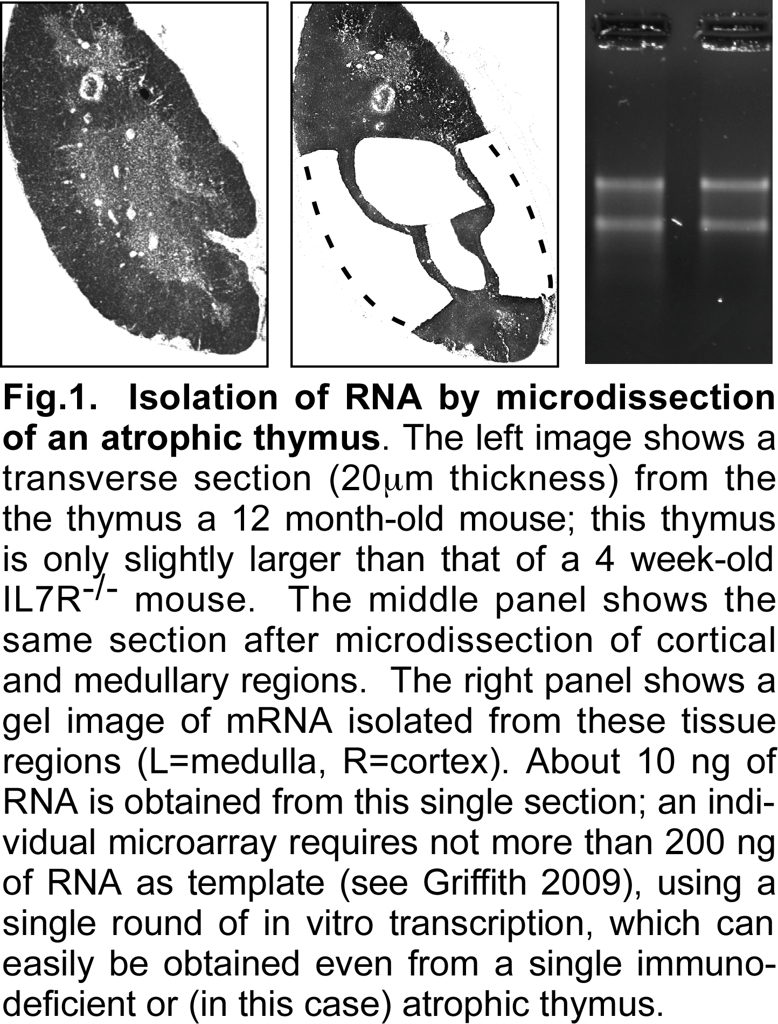
Notably, the signals that lymphoid cells provide to stromal cells to induce their proliferation, differentiation, and/or survival are completely unknown. As mentioned above, the historical perspective of the thymus is lympho-centric, a view that is understandable since production of lymphoid cells is the main function of the thymus. This perspective is further exacerbated by the ease with which lymphoid and other hematopoietic cells are manipulated in experimental systems; in contrast, isolation and manipulation of thymic stromal cells is quite challenging, particularly in the hypotrophic state that accompanies lymphoid immunodeficiencies. To meet this challenge, we have devised a computational method for global identification of stromal gene expression in situ (Griffith et al., 2009). In brief, RNA isolated from microdissected tissue (cortex, medulla, or any other region of interest) is used to measure gene expression using cDNA microarrays. Simultaneously, gene expression in the lymphocytes that correspond to that region (isolated from other thymuses) is also measured by microarray. Stromal gene expression can be defined as gene expression in the tissue that is not attributable to gene expression by the corresponding lymphoid cells. The validity of this approach has been demonstrated by its ability to capture virtually all of the genes that are known to characterize stromal cells in the (young) thymus, including known stromal signals for developing lymphoid cells (e.g., Notch ligands, IL7, kit ligand, Cxcl12, MHC proteins, etc.), as well as genes known to be intrinsically required for stromal development or function (e.g., Foxn1, Pax1, Egfrs, etc.). This approach has several advantages over conventional approaches to studying thymic stromal cells. For one, there are no changes in gene expression caused by disruption of the 3D context of the thymus, or by enzymatic digestions or lengthy incubations at 37ºC. This approach is also non-biased, and returns information on all of the stromal cells in a given region (the exact identify can be established later, using immunohistochemistry, RNA in situ hybridization, etc.). Most importantly for the current proposal, this approach requires very little tissue, and thus is amenable to the study of stromal cells in hypotrophic or atrophied tissues, such as the one proposed here (see Fig.1).

The goal of the current proposal is to understand how thymic stromal cells respond to the presence of lymphoid cells by activating latent pathways for growth, differentiation, and/or survival. We will focus on stromal receptor:lymphoid ligand interactions. Since stromal cells clearly and undeniably respond to the presence of lymphoid cells by
Research Strategy Page 24

proliferation and differentiation (for an example, see Penit et al., 1996), such interactions must exist. The model system we will use is represented by IL7R-deficient mice (Peschon et al., 1994) that have been injected with wildtype lineage-negative bone marrow, as previously described by our group (Prockop and Petrie, 2004). Several advantages of this model system make it ideal for the purpose of this project. First, the stromal cells themselves are inherently normal in IL7R^{-/-} mice, and only the lymphoid cells are affected by mutation of the IL7R. Second, the IL7R^{-/-} thymus undergoes profound growth in response to the presence of normal stem/progenitor cells (Prockop and Petrie, 2004), which is the function that is to be studied. Third, this response can be induced without the need for myeloablative conditioning of recipient mice (Prockop and Petrie, 2004), and thus, the damaging effects of ablative regimens on thymic stromal cells (reviewed in Heng et al., 2010) will be avoided. Finally, the (unmanipulated) IL7R^{-/-} thymus contains visible and organized (albeit hypotrophic) cortical and medullary regions, whereas other immunodeficient mouse models do not (for an example, see Prockop and Petrie, 2004). This characteristic allows us to establish baseline gene expression in stromal cells from a hypotrophic thymus, from which point changes that occur in response to an expanding lymphoid population will be measured.

Understanding how lymphoid cells induce thymic stromal responses has been a subject of contemplation for many laboratories for many years. However, given the difficulties associated with thymic stromal cell isolation (described earlier), and the further limitation imposed by the small number of cells present in the immunodeficient thymus, it has been a very difficult issue to address. The combination of our stromal gene mapping approach (Griffith et al., 2009), together with the IL7R^{-/-} growth model (Prockop and Petrie, 2004), now gives us the opportunity address this issue in a comprehensive manner. The methods have already been established and documented in peer-reviewed publications, and thus, no lengthy methodological development will be necessary. So little is known about how stromal cells respond to the presence of lymphocytes that even a few clues regarding this process would be a major advancement. Instead, we propose to characterize this response in global detail, with the intention of publishing the results of these gene expression studies, as well as probing the molecular mechanisms of this response in biological model systems.

Our goal is to characterize how lymphoid cells induce stromal growth, differentiation, and/or survival in the fully formed (but hypocellular) thymus. We wish to emphasize that this is distinct from the somewhat related functions that occur during embryonic organogenesis of the thymus, including specification of the thymic primordium (which is lymphoid-independent), and divergence of cortical and medullary stromal lineages. While the approach described in this project may be suitable for probing those questions, they are distinctly different, and should not be confused with the goals of the current project, which is to understand the signals that induce growth, differentiation, and/or survival of stromal cells after the nascent organ has been formed.

INNOVATION.

As described above, the vast majority of studies on the thymus have focused on the role that the stromal microenvironment plays in supporting lymphoid differentiation. In contrast, the role that the lymphoid cells play in establishing the overall microenvironment is very poorly understood. In particular, the mechanism by which stromal cells respond to the presence of lymphoid cells by undergoing proliferation and post-mitotic differentiation (Penit et al., 1996) is virtually unknown. This project seeks to address this paucity in a comprehensive and physiologically relevant fashion, and therefore is both novel and innovative. Further, the experimental approaches (in situ stromal gene mapping in a non-myeloablative model system of induced thymic growth) are technologically novel. The combination of these techniques seems highly likely to provide a wealth of information on this biologically important question with little risk of failure, given that these technologies are already very well established in our laboratory.

APPROACH.

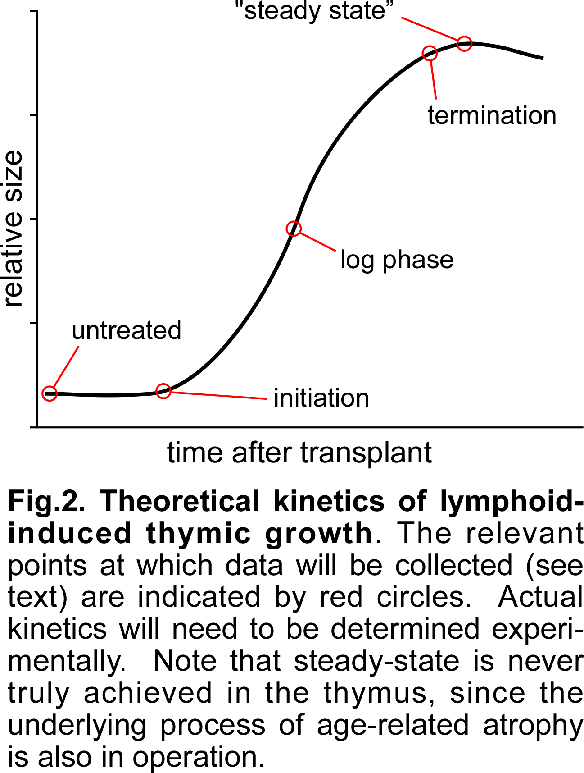
AIM 1. DEFINE DYNAMIC CHANGES IN GENE EXPRESSION IN STROMAL CELLS IN AN INDUCIBLE MODEL OF THYMIC ORGAN GROWTH. The goals of this Aim are to use our differential stromal gene mapping approach (Griffith et al., 2009) in an inducible model of growth (intravenously transplanted IL7R^{-/-} mice, Prockop and Petrie, 2004) to identify the genes expressed by stromal cells during the response to the influx and expansion of lymphoid cells. We will isolate intact cortical and medullary regions from one lobe of the thymus from 4 week-old IL7R^{-/-} (male) mice, and simultaneously, will sort cortical (CD3^{-/lo} AND CD45⁺ AND (CD90⁺ OR CD117⁺)) and medullary (CD3^{hi} CD45⁺) lymphoid cells from the other lobe. We will perform 3 independent microarrays for each sample type (cortical or medullary, tissue or lymphoid), and each microarray will represent pooled RNA from 3 individual mice. We will repeat this entire procedure at key points after intravenous injection of 2.5 x 10⁶ wildtype lineage-negative bone marrow cells (Prockop and Petrie, 2004); the points will be chosen to represent the time at which thymic growth is first initiated, the time at which thymus size reaches its peak, a time point intermediate to these, and a time point approximately 36 hours before the peak (Fig.2). Functionally, these correspond to baseline (untransplanted), growth initiation, steadystate (although some overshoot is expected), log phase growth, and termination of growth, respectively. The significance of most of these time points is hopefully obvious. The “termination of growth” time point may warrant some additional explanation, since this time point is not really essential to understanding the growth process. However, the molecular mechanisms for how size is limited in any organ are still poorly understood, especially in vertebrates. Consequently, the simple addition of this time point will allow us to identify the changes that precede the cessation of organ growth, and how these differ from the steady state, thus greatly expanding the overall impact and potential implications of the project.

Although we have shown that the IL7R^{-/-} thymus responds to the presence of wildtype lymphocytes by robust growth (Prockop and Petrie, 2004), we do not know the precise kinetics of this response. Since the precise timing of the analytical intervals illustrated in Fig.2 is relatively important, we will first perform preliminary experiments to determine the kinetics of induced growth in this model. Based on existing knowledge regarding the kinetics of fetal thymic growth (about 10 days, assuming formation of the primordium around e10), the kinetics of one complete wave of post-natal T cell development (about 20 days, see Porritt et al., 2003; Shortman et al., 1990), and the partial kinetics of reconstitution in RAG-deficient mice (about 20+ days, see Penit et al., 1996), we will perform an initial series of kinetic analyses in which the size of the thymus in IL7R^{-/-} mice will be measured 0, 4, 8, 12, 16, 20, 24, 28, and 32 days after transplantation with wildtype cells. This will involve 3 mice at each time point, transplanted with 2.5 x 10⁶ lineage-depleted, wildtype bone marrow cells. We expect that a second kinetic series will need to be performed, including serial 1-day time points just prior to the point at which the onset of growth is observed in the first experiment (to more precisely determine when this process begins), as well as on both sides of the peak (to determine when the peak actually occurs and, by definition, the “termination of growth” time point). From these experiments, we will proceed with the kinetic analysis illustrated in Fig.2 and described above.

Using the statistical and computational methods previously described by us (Griffith et al., 2009), we will identify stromal gene expression at each stage of the growth process by comparing gene expression in purified cortical or medullary lymphocytes to that of the corresponding tissue. Once stromal gene expression levels have been calculated for each gene (probeset) on the chip (Affymetrix MOE430_2, representing all genes and ESTs), we will set arbitrary thresholds to distinguish genes that are expressed from those that are not. The conventional threshold for this purpose is the median signal value, which operates under the assumption that any given cell type expresses roughly 50% of all genes in the genome. However, since gene expression signals exhibit a Poisson distribution, the use of any arbitrary threshold to establish a binary outcome (expressed/not expressed) is inherently flawed (i.e., some genes below the threshold are actually expressed, and some genes above the threshold are not). Consequently, while the 50th percentile will be used as a default present/absent threshold, we may also apply different thresholds (40th or 60th percentile) to increase or decrease stringency, depending on the outcomes and objectives (see further discussion in Aim 3). Note that present/absent detection calls (determined by the weighted statistical difference between signals for perfect match and single base mismatched probes in each probeset) cannot be accurately used for calculated stromal signals, since they cannot distinguish lymphoid from stromal gene expression in microdissected tissue. However, they can be used to eliminate genes that are not expressed at all in the thymus; probesets where <2 (out of 3) present detection calls are found in any given tissue will be flagged, since these are unlikely to be present in either lymphoid or stromal cells. Further, genes with ≥2 present calls in tissue AND <2 present calls in lymphoid cells will also be flagged, as these are likely to represent stromal specific genes (i.e., they are expressed in tissue, but not in the lymphoid component of the tissue), an important subset of all stromal genes (Griffith et al., 2009). The identification of all genes expressed by stromal cells during lymphoid-induced growth, as described above, will subsequently be used to identify stromal receptors that may detect the presence of lymphoid cells, and/or transduce a response to lymphoidderived signals, as described in Aim 2.

Research Strategy Page 26
It is important to consider that the (young) IL7R^{-/-} thymus contains some (IL7R^{-/-}) lymphoid cells, and gene expression signatures in these lymphoid cells are expected to be quite different than that of wildtype cells. Thus, the lymphoid signal in the reconstituted thymus will gradually shift from an IL7R^{-/-} signature to a combination of IL7R^{-/-} and wildtype, and then to essentially all wildtype. This will not impair our ability to identify stromal gene expression in these tissues, because we will not be comparing lymphoid gene expression between time points (which would certainly reveal differences in the context of a growing thymus, even if only wildtype cells were present). Instead, data from lymphoid cells will only be used to identify the stromal component of gene expression in tissue at the corresponding time point, i.e., an internally matched comparison. Once stromal signatures have been established at each time point, stromal-to-stromal changes over time will be evaluated. Lymphoid gene expression may be re-queried at that point to determine whether relevant ligands are expressed (see Aim 2). However, lymphoid cells will not be compared to each other across different time points, and thus, differences in gene expression between IL7R^{-/-} and wildtype lymphoid cells are irrelevant. It is also important to consider why the IL7R^{-/-} lymphoid cells that are present in unmanipulated IL7R^{-/-} thymuses do not stimulate stromal growth. This stems from the fact that most lymphocytes in the thymus of young IL7R^{-/-} mice are the remnants of fetal hematopoietic development (originating in the liver); since fetal thymocytes do not depend on IL7 (for example, see Balciunaite et al., 2005), the fetal thymus in IL7R^{-/-} mice can form and compartmentalize, but the continued growth that accompanies the arrival of definitive progenitors is absent. In fact, by a later age (~10 weeks), IL7R^{-/-} mice exhibit an almost complete arrest at the DN2 stage of development (Crompton et al., 1998), consistent with high levels of IL7R expression at that stage in normal mice (Allman et al., 2003; Porritt et al., 2004). Thus, the lymphoid component of the thymus in young IL7R^{-/-} mice is actually collapsing, resulting in stromal degeneration and a profoundly hypoplastic organ that can nonetheless be rescued by wildtype progenitor cells (Prockop and Petrie, 2004). It is this response that we seek to characterize.

AIM 2. IDENTIFY STROMAL RECEPTOR:LYMPHOID LIGAND PAIRS AMONG GENES EXPRESSED DURING INDUCED THYMIC GROWTH. The data generated in Aim 1 will provide a list of all genes expressed in stromal (and lymphoid) cells during the induced growth process. In this Aim, we will identify those stromally expressed genes that encode receptor proteins, and then verify the presence of the corresponding ligand (or counterreceptor) in the lymphoid population. We will merge two independent approaches for this objective. The first utilizes the Human Plasma Membrane Receptome database (www.receptome.org/HPMR). Most protein:protein interaction and signaling resources do not focus on receptor-ligand interactions (e.g. www.signaling-gateway.org), or only include a subset of receptor:ligand interactions (http://dip.doembi.ucla.edu/dip/DLRP.cgi). In contrast, the HPMR resource is a comprehensive database of more than 900 receptors and 600 paired ligands; this database was built using proteomic sequence analyses (multi alignments and domain associations), followed by manual curation of each record with information from the literature (Ben-Shlomo et al., 2003). In order to speed our batch query and gene mapping needs, the HPMR group has provided us with their entire database (see letter of support), including MOE430_2 (mouse) probeset IDs that will allow us to easily identify receptors expressed in our kinetic database of stromal growth, and likewise for lymphoid data. This powerful database virtually assures success in identifying a large variety of receptor:ligand interactions, even without other parallel approaches.

The second approach uses Boolean combinations of gene ontology terms (primarily molecular function ontologies), together with automated searching of literature resources (PubMed, PubMed Central), to identify co-occurrence of receptor:ligand terms (gene symbols and aliases) in published literature. To generate our own list of receptors and ligands, we developed a manually curated list of well known genes corresponding to those function, and used them to model a Boolean hierarchy of gene ontologies that included as many of our genes as possible, while simultaneously excluding inappropriate genes (noise). For instance, a list of receptors was built from the ontologies “receptor activity (004872) OR receptor complex (043235) OR plasma membrane (005886) OR intrinsic to membrane (031224) OR integral to membrane (016021) OR external side of plasma membrane (009897) OR cell surface (009986)], but NOT [golgi apparatus (005794) OR endoplasmic reticulum (005783) OR cytoplasm (005737)], except those that also appear in [extracellular region part (044421) OR plasma membrane (005886) OR cell surface (009986) OR secretion (046903).” A similar approach was used for identification ligands (not shown in the interest of space). Note that receptors may also be ligands (e.g., CD28/CD80,86), such that both the “receptor” and the “ligand” list will be applied to lymphoid data to identify potential binding partners for stromal receptors. Multiple probesets for individual receptors or ligands (where they exist) will be collapsed into a single EntrezGene identifier using the GeneSet Enrichment Analysis tool (www.broadinstitute.org/gsea). An automated script will then be used to search relevant literature databases for the co-occurrence (co-citation) of every term in the receptor list receptor with each term in the ligand/counter-receptor list. Individual publications citing more than 20 total genes (i.e.,

genomic analyses) will be eliminated, since co-occurrence in such publications is unlikely to be related to functional interaction. To increase statistical power, both human and mouse homologs will be searched. Since the starting lists are heavily biased towards receptors and ligands, frequent co-occurrence is likely to represent cognate receptor:ligand pairs. Note that this second approach (Boolean ontologies and literature co-occurrence) will generate a much larger (noisier) list than the first approach, but it has the advantage of an integrated scoring (priority) system, in the form of co-occurrence frequency (i.e., high frequencies of cooccurrence are likely to be more biologically important, and also to have existing genetic tools). As will be described in Aim 3, co-occurrence score and the availability of genetic model systems, together with other parameters, will be used to prioritize the outcomes (which are expected to include a relatively large number of potential interactions, based on similar studies we have performed in young wildtype mice). Integration of the results of both approaches into a single database, such that the list can be sorted using either approach, or both, will minimize the limitations of either approach while retaining the strengths of each. Note that a mandatory requirement for the presence of both a receptor (stromal) and its ligand (lymphoid) in the thymus will substantially reduce the frequency of false positives, since the probability of a falsely identifying a receptor as being expressed in stromal cells AND identifying its ligand as being expressed in lymphoid cells is the square of the two probabilities. This is a very significant advantage in discriminating between genes found by random chance, and those that are likely to be functional.

AIM 3. PRIORITIZE CANDIDATE LYMPHOID → STROMAL SIGNALS. The studies described in Aims 1 and 2 will generate a single, searchable, sortable database of genes expressed by stromal and lymphoid cells during lymphoid induced growth, and will identify receptor:ligand pairs among these. As described above, the frequency of receptor:ligand co-occurrence can be used to establish a preliminary prioritization scheme, where genes that are frequently co-cited are likely to be of relatively high biological importance. In this Aim, several additional scoring parameters will be added to strengthen overall priorities. One of the most important is the generation of a thymus-specific score. The approach is similar to that for generating a literature cooccurrence score for receptors and ligands, except that in this case, PubMed and PubMed Central databases will be searched for the co-occurrence of the receptor or ligand in the context of the thymus (i.e., using the search terms “thymus” or “thymic” or “thymocyte”). Receptor:ligand pairs that are frequently co-cited with each other (high biological importance), but infrequently cited in reference to the thymus (or not at all), will represent very high priority candidates. Further, an overall score can also be developed, as defined by (receptor:ligand score / thymus score). As another scoring metric, we will also perform ANOVA on the dynamic (time course) data for stromal receptor gene expression; gene signals that change the most (smallest q value, equivalent to p value corrected for multiple testing) can be prioritized, since these are likely to encode receptors that change the most during the kinetic response to lymphoid cells. Again, the ANOVA q value can be utilized independently for prioritization, or this attribute can be combined with any (or all) of the other scores to generate an overall score. The decile in which a receptor signal occurs (i.e., the relative signal intensity) may also be used for prioritization; this may be especially important for gene signals that are near the median expression value (e.g., 40th to 60th percentile; see Aim 1), since higher confidence can be assigned to genes that are more highly expressed.

Although these scoring methods are likely to be sufficient for prioritization of the receptor:ligand results, we will implement additional quantitative criteria as well. One particularly powerful approach is represented by the STRING (Search Tool for the Retrieval of Interacting Genes and Proteins) database (www.string-db.org). This represents a comprehensive database dedicated to identifying and scoring the relevance of protein:protein interactions, using informatic and experimental resources. Protein interaction data represented by multiple independent resources (MINT, HPRD, BIND, DIP, BioGRID, KEGG, Reactome, IntAct, EcoCyc and NCI-Nature) are included in the STRING interaction database. Importantly, STRING can generate scores based on multiple types of evidence; most relevant for the present project is STRING’s own version of a literature co-citation score, as well as the strength of experimental (as opposed to informatic) evidence. Based on these and other scoring criteria, STRING can also generate an overall confidence score that, again, can be used independently, or combined with any of the scores described above as a metric for prioritization.

In addition to these quantitative metrics, other more qualitative (but nonetheless useful) criteria will be applied for final prioritization. For one, automated scripts (already generated) will be used to parse relevant genetic resources (Jax Mouse Genome Informatics, NCRR Mouse Mutant Resource Centers, the Knockout Mouse Repository, etc.), providing a direct link (hyperlink) from genes in our database to existing genetic models (mutant mice, ES cells, or targeting vectors), where they exist. This will allow us to rapidly identify receptor:ligand candidates that are amendable to biological testing (Aim 4) within the short timeframe of this project. The same approach can be used to parse reagent databases (Addgene, GeneCards, Abcam) for other valuable resources, such as antibodies, siRNAs, expression vectors, etc. A further independent approach will be to organize the dynamic stromal receptor data into hierarchical clusters (k means clustering); receptors in clusters that (upon visual examination) appear to be characteristic of specific phases of the growth process will be flagged in the database as being potentially more interesting than clusters that map to multiple phases. For instance, a cluster of genes (receptors) that is specifically upregulated (or downregulated) at the “initiation of growth” phase (Fig.2) might be expected to contain receptors play a key role in early response to lymphoid signals. Finally, manual evaluation of high-priority candidates in the receptor:ligand list for those with known relevance in processes such as proliferation, differentiation, or survival, especially in cells of epithelial or mesenchymal origin (the primary stromal lineages in the thymus) will also be performed. In this respect, it is important to note that high-throughput approaches (such as the one described above) generate large numbers of results that are not amenable to manual curation unless other criteria can be first applied to help to establish preliminary priorities. Thus, the multi-faceted, redundant, and quantitative scoring approaches described earlier are essential in allowing final (qualitative) prioritization methods to be applied. The combination of all these approaches will be used to advance a few select candidates to Aim 4.

AIM 4. ESTABLISH BIOLOGICAL RELEVANCE FOR ONE OR MORE HIGH-PRIORITY LYMPHOID → STROMAL SIGNALS. The goals of the previous Aims are to characterize the stromal gene expression response to lymphoid cells in global detail. While this is intellectually interesting, it is also important to establish the biological relevance of the predictions made by our approach. The financial resources that can be provided by the R21 mechanism are limited. However, for a few select candidates that meet all of the above criteria (stromal receptor, lymphoid ligand, high co-occurrence/thymus/overall scores, low ANOVA q value, known biological relevance, availability of genetic models, etc.), the path to establishing biological relevance is clear. The two most obvious approaches are 1) viable germline mouse mutant alleles (alternatively, conditional mutant alleles) of the lymphoid ligand, and 2) viable germline mouse mutant alleles (or conditional mutant alleles) of the stromal receptor. In the case of conditional alleles, deletion would be mediated by crossing to hCD2[Cre] (de Boer et al., 2003) for lymphoid ligands, or Foxn1[Cre] (Gordon et al., 2007) for stromal epithelial receptors; both strains are already in our laboratory. Regardless of the tissue target (lymphoid or stromal, conditional or germline), valid candidates would be expected to have a hypocellular thymus. In many respects, a lymphoid (ligand or counter-receptor) model system would be preferable, since in this case, transplantation of lineage-negative marrow from mutant mice into IL7R^{-/-} recipients would be expected to exhibit absence of the induced growth response, providing very clearly evidence of the presence of a lymphoid signal for stromal cells. Downstream experiments (outside of the context of this application) would include more detailed characterization of the stromal response, including an understanding of the type of signal being transmitted (proliferation, differentiation, survival). An in-depth description of these is premature at this point, and not specifically relevant to the current proposal.

In conclusion, we have the technology and the expertise to make a significant impact on the poorly understood process of how stromal cells respond to the presence of lymphocytes to shape the microenvironment for steady-state lymphopoiesis. We wish to reemphasize that we possess documented (published) expertise in all of the relevant methodologies, as well as in interpreting complex outcomes in a meaningful fashion. Our commitment to providing the unique data resources generated by these highthroughput approaches to the scientific community at large is also documented. Thus, we believe that the proposed studies are important, highly feasible, and will fuel progress and an understanding of the underlying process by facilitating the work of many other research groups.

TIMELINE. Most of the first 6-8 months of the project will be spent determining the kinetics of growth in the IL7R^{-/-} model, and then performing microdissection/cell sorting at the relevant time points. The next 6-8 months will consist almost exclusively of data analysis and prioritization of the outcomes. The remaining time (8-12 months) will be spent refining the outcomes for publication, as well as performing tests of biological relevance using existing genetic models, as outlined in Aim 4. Additional information on the timeline is included in the Personnel Justification.
VERTEBRATE ANIMALS

- Mice: a total of 420 mice are requested for the project. The main experiment described in Aim 1 will involve 5 time points, each of which will be represented by 3 microarrays, each of which will contain tissue from three IL7R^{-/-} mice, for a total of 45 mice. However, only males will be used to minimize variation, so the actual number of IL7R^{-/-} mice required is 90. For each of these, one sex-matched wildtype donor (C57BL/6) will be required (90 mice). For the preliminary establishment of growth kinetics, there will be 9 time points represented by 3 IL7R^{-/-} mice each; again, only males will be used as recipients, and an equal number of sexmatched wildtype donors will be required, so the number of mice required for this experiment is 108. A second preliminary experiment to determine more precisely the points corresponding to initiation of growth and peak size will require an equal number of mice (108). Note that in some cases, it may be possible to transplant multiple IL7R^{-/-} recipients with marrow from a single donor, depending on the availability of recipient and donor mice of the proper age at the same time. If this is possible, we will do so, which will reduce the numbers of wildtype donor mice required by some proportion. In addition to the above experimental mice, each strain (IL7R^{-/-} and C57BL/6) will need to be bred, involving one breeding male and two breeding females for each strain, replaced every six months for the duration of the project (24 mice). Some additional mice will be required for Aim 4 (biological validation of select high-priority candidates). The number depends on many factors, including whether the model strain is a germline or conditional mutant, and whether it is a lymphoid or stromal model. An amendment to animal numbers will be filed to reflect the appropriate number, depending on these parameters. However, as a preliminary estimate, the number is expected to be small, generally <200 total mice for these preliminary validation experiments.

- Animals must be used because we are examining the function of the thymus as an organ, and there are no artificial thymic organs, or any way to recapitulate the function of the thymus in vitro. Numbers of animals were justified in section 1.

- Veterinary care is provided by Animal Resources Center staff, which carries out a variety of laboratory diagnostic procedures and provides oversight for the TSRI rodent preventive health quality assurance program. Services are provided either “in-house”, or are referred to outside laboratories as is necessary. Necropsy and histopathology can be performed according to investigator needs, from basic or comprehensive diagnostic studies to tissue-specific or comprehensive research studies (e.g., preclinical toxicology safety studies, mutant mouse phenotype studies). Complementary clinical pathology procedures may be included as part of the comprehensive work-ups. Clinical pathology work can also be provided, including: (1) clinical hematology, including: complete blood counts, differential white blood cell counts, reticulocyte counts, platelet counts, hematocrit; (2) serum biochemistry; (3) parasitology; (4) cytology, (5) microbiology; (6) urinalysis, (7) diagnostic serology for specific animal pathogens, (8) molecular biology for specific animal pathogens.

- Animals undergoing more than momentary distress (needle stick, etc.) will be anesthetized using standard protocols (isoflurane, buprenorphine, ketamine/xylazine). Subsequent to any invasive procedure, animals will be monitored until recovery from anesthesia, and at least daily for the first week thereafter, for adverse symptoms including hunched posture, loss of hair, weight loss, lethargy, or other symptoms of abnormal appearance or behavior. Mice will be treated as recommended by the attending veterinarian, or if more appropriate, euthanized to relieve severe discomfort.

- Euthanasia will be performed by carbon dioxide asphyxiation followed by thoracotomy. This method is consistent with the recommendations of the Panel on Euthanasia of the American Veterinary Medical Association.
Vertebrate Animals Page

BIBLIOGRAPHY AND REFERENCES

Allman, D., Sambandam, A., Kim, S., Miller, J. P., Pagan, A., Well, D., Meraz, A., and Bhandoola, A. (2003). Thymopoiesis independent of common lymphoid progenitors. Nat Immunol 4, 168-174.
Balciunaite, G., Ceredig, R., Fehling, H. J., Zuniga-Pflucker, J. C., and Rolink, A. G. (2005). The role of Notch and IL-7 signaling in early thymocyte proliferation and differentiation. Eur J Immunol 35, 1292-1300.
Ben-Shlomo, I., Yu Hsu, S., Rauch, R., Kowalski, H. W., and Hsueh, A. J. (2003). Signaling receptome: a genomic and evolutionary perspective of plasma membrane receptors involved in signal transduction. Sci STKE 2003, RE9.
Crompton, T., Outram, S. V., Buckland, J., and Owen, M. J. (1998). Distinct roles of the interleukin-7 receptor alpha chain in fetal and adult thymocyte development revealed by analysis of interleukin-7 receptor alphadeficient mice. Eur J Immunol 28, 1859-1866. de Boer, J., Williams, A., Skavdis, G., Harker, N., Coles, M., Tolaini, M., Norton, T., Williams, K., Roderick, K., Potocnik, A. J., and Kioussis, D. (2003). Transgenic mice with hematopoietic and lymphoid specific expression of Cre. Eur J Immunol 33, 314-325.
Fischer, A., Le Deist, F., Hacein-Bey-Abina, S., Andre-Schmutz, I., Basile Gde, S., de Villartay, J. P., and Cavazzana-Calvo, M. (2005). Severe combined immunodeficiency. A model disease for molecular immunology and therapy. Immunol Rev 203, 98-109.
Goldschneider, I., Komschlies, K. L., and Greiner, D. L. (1986). Studies of thymocytopoiesis in rats and mice. I. Kinetics of appearance of thymocytes using a direct intrathymic adoptive transfer assay for thymocyte precursors. J Exp Med 163, 1-17.
Gordon, J., Xiao, S., Hughes, B. r., Su, D. M., Navarre, S. P., Condie, B. G., and Manley, N. R. (2007). Specific expression of lacZ and cre recombinase in fetal thymic epithelial cells by multiplex gene targeting at the Foxn1 locus. BMC Dev Biol 7, 69.
Griffith, A. V., Fallahi, M., Nakase, H., Gosink, M., Young, B., and Petrie, H. T. (2009). Spatial mapping of thymic stromal microenvironments reveals unique features influencing T lymphoid differentiation. Immunity 31, 999-1009. PMCID: PMC2807413.
Heng, T. S., Chidgey, A. P., and Boyd, R. L. (2010). Getting back at nature: understanding thymic development and overcoming its atrophy. Curr Opin Pharmacol 10, 425-433. PMID: 20483662.
Mohtashami, M., and Zuniga-Pflucker, J. C. (2006). Three-dimensional architecture of the thymus is required to maintain delta-like expression necessary for inducing T cell development. J Immunol 176, 730-734.
Penit, C., Lucas, B., Vasseur, F., Rieker, T., and Boyd, R. L. (1996). Thymic medulla epithelial cells acquire specific markers by post-mitotic maturation. Dev Immunol 5, 25-36.
Peschon, J. J., Morrissey, P. J., Grabstein, K. H., Ramsdell, F. J., Maraskovsky, E., Gliniak, B. C., Park, L. S., Ziegler, S. F., Williams, D. E., Ware, C. B., Meyer, J. D., and Davison, B. L. (1994). Early Lymphocyte Expansion Is Severely Impaired in Interleukin 7 Receptor-deficient Mice. J Exp Med 180, 1955-1960.
Petrie, H. T., and Zuniga-Pflucker, J. C. (2007). Zoned out: functional mapping of stromal signaling microenvironments in the thymus. Annu Rev Immunol 25, 649-679.
Porritt, H. E., Gordon, K., and Petrie, H. T. (2003). Kinetics of steady-state differentiation and mapping of intrathymic-signaling environments by stem cell transplantation in nonirradiated mice. J Exp Med 198, 957962.
Porritt, H. E., Rumfelt, L. L., Tabrizifard, S., Schmitt, T. M., Zuniga-Pflucker, J. C., and Petrie, H. T. (2004). Heterogeneity among DN1 prothymocytes reveals multiple progenitors with different capacities to generate T cell and non-T cell lineages. Immunity 20, 735-745.
Prockop, S. E., and Petrie, H. T. (2004). Regulation of thymus size by competition for stromal niches among early T cell progenitors. J Immunol 173, 1604-1611.
Scollay, R., Smith, J., and Stauffer, V. (1986). Dynamics of early T cells: prothymocyte migration and proliferation in the adult mouse thymus. Immunol Rev 91, 129-157.
Shortman, K., Egerton, M., Spangrude, G. J., and Scollay, R. (1990). The generation and fate of thymocytes. Semin Immunol 2, 3-12. van Ewijk, W., Hollander, G., Terhorst, C., and Wang, B. (2000). Stepwise development of thymic microenvironments in vivo is regulated by thymocyte subsets. Development 127, 1583-1591. van Ewijk, W., Shores, E. W., and Singer, A. (1994). Crosstalk in the mouse thymus. Immunol Today 15, 214-
217.
References Cited Page

RESOURCE/DATA SHARING PLAN

Within the constraints imposed by the Scripps Research Institute (below), all data generated by this project will be shared via peer reviewed publications. In addition, the PI or other project staff may describe the related findings in public or private lectures (conferences, seminars, etc). Scripps policy dictates that if the nature of the final research data necessitates restrictions on the access to and use of the data, such restrictions shall be determined at the time such data is generated. In addition, any rights and obligations to third parties are consistent with the terms and conditions of the NIH award to ensure proper dissemination of final research data. It is anticipated that final research data shall be made available no later than the acceptance for publication of the main findings from the final dataset. However, TSRI reserves the right to delay disclosure of research findings for an additional sixty (60) days in order to allow TSRI to exercise its intellectual property rights. The format or presentation of final research data shall be determined at the time such data is generated and in accordance with generally accepted scientific standards. Final progress reports shall include information detailing the steps towards implementation of additional data-sharing plans. If unique genetic (mouse) resources are generated by this project, they will be shared as mandated in NOT-OD-04-042.
Resource Sharing Plan Page 35
PHS 398 Checklist
OMB Number: 0925-0001

1. Application Type:
From SF 424 (R&R) Cover Page. The responses provided on the R&R cover page are repeated here for your reference, as you answer the questions that are specific to the PHS398.
* Type of Application:
Federal Identifier:
New
Resubmission
Renewal
Continuation
Revision
2. Change of Investigator / Change of Institution Questions
Change of principal investigator / program director
Name of former principal investigator / program director:
Prefix:
* First Name:
Middle Name:
* Last Name:
Suffix:
Change of Grantee Institution
* Name of former institution:

3. Inventions and Patents (For renewal applications only)
- Inventions and Patents:
No
Yes
If the answer is "Yes" then please answer the following:
- Previously Reported:
No
Yes
Checklist Page 36
!""""#
4. * Program Income
Is program income anticipated during the periods for which the grant support is requested?
Yes
No
If you checked "yes" above (indicating that program income is anticipated), then use the format below to reflect the amount and source(s). Otherwise, leave this section blank.
*Budget Period *Anticipated Amount ($) *Source(s)

5. * Disclosure Permission Statement
If this application does not result in an award, is the Government permitted to disclose the title of your proposed project, and the name, address, telephone number and e-mail address of the official signing for the applicant organization, to organizations that may be interested in contacting you for further information (e.g., possible collaborations, investment)?
No
Yes
Checklist Page 37
!""""#

